
Low Level Concerns Policy
September 2025

Version | Date | Author | Status | Summary
1.0 | September 2021 | R.Park | Approved | LLC Policy as referred to in the Safeguarding Policy, Child Protection policy and Code of Conduct Policy.  Adopted policy from the MOP
2.0 | September 2022 | R.Park | Approved
3.0 | September  2023 | Z.Wisken | Approved | LLC Policy as referred to in the Safeguarding Policy, Child Protection policy and Code of Conduct Policy.  Adopted policy from the MOP 2023
4.0 | September 2024 | Z.Wisken | Approved | LLC Policy as referred to in the Safeguarding Policy, Child Protection policy and Code of Conduct Policy.  Adopted policy from the MOP 2023  ZW checked for any changes.
5.0 | September 2025 | Z.Wisken |  | LLC Policy as referred to in the Safeguarding Policy, Child Protection policy and Code of Conduct Policy.  Adopted policy from the MOP 2023  ZW checked for any changes.

Reviewed By: Full Governing Body
1 Year Policy
Date of Review: September 2025
Expiry Date: September 2026
Signed by:  Headteacher | 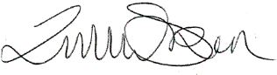
Signed by:  Chair of Governors | 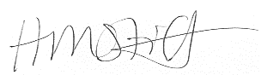

Low Level Concerns Policy

1.0 Policy statement

1.1 Our school recognises its statutory and moral duty to safeguard and promote the welfare of pupils and understands that staff play a vital role in meeting these responsibilities.

1.2 Our school works to ensure that we promote an open and transparent culture in which all concerns about adults working in or on behalf of the school are dealt with promptly and appropriately.

2.0 Scope

2.1 All employees employed at this school including:
- Teachers
- Support staff
- Supply teachers
- Volunteers
- Local Authority visiting staff
- Contractors
2.2 The term ‘staff’ throughout this policy refers to all of the above.

3.0 Policy aims

3.1 To help create a culture in which all concerns about adults are shared responsibly and with the right person and are recorded and dealt with appropriately.

3.2 To enable schools to identify concerning, problematic or inappropriate behaviour early.

3.3 To minimise the risk of abuse occurring.

3.4 To ensure that adults working in or on behalf of the school are clear about professional boundaries and act within these boundaries and in accordance with the ethos and values of the school.

3.5 To help create an environment where staff are comfortable to self-refer, where, for example, they have found themselves in a situation which could be misinterpreted, might appear compromising to others, and/or on reflection they believe they have behaved in such a way that they consider falls below the expected professional standards.

4.0 Definition

4.1 The term ‘low level’ concern does not mean that it is insignificant. It means that the behaviour towards a child does not meet the harm threshold for an allegation.

4.2 ‘Keeping Children Safe in Education’ defines a low level concern as:
“any concern – no matter how small, and even if no more than causing a sense of unease or a ‘nagging doubt’ – that an adult working in or on behalf of the school or college may have acted in a way that:

- is inconsistent with the staff code of conduct, including inappropriate conduct outside of work; and
- does not meet the allegations threshold or is otherwise not considered serious enough to consider a referral to the LADO”

5.0 Avoiding low level concerning behaviour

5.1 Behaviour defined as a ‘low level concern’ can exist on a spectrum, from the inadvertent or thoughtless, or behaviour that may look to be inappropriate but is not in specific circumstances, through to that which is ultimately intended to enable abuse.

5.2 Staff education and reinforcement on avoiding circumstances which may put them in a difficult situation is key to avoiding the need for dealing with these types of concerns.

5.3 Our school ensures that staff are clear about what appropriate behaviour is through their induction and regularly reinforcement of documents such as:
- Staff Code of Conduct ▪ ‘Avoiding Allegations’ guidance
- Safeguarding and Child Protection policies and regular training ▪ Teachers’ Standards (for teaching staff)

6.0 Reporting a low level concern

6.1 Low level concerns about a member of staff should be reported to the DSL and/or Headteacher as per the school’s Child Protection procedures. If the concern is about the Headteacher this should be reported to the Chair of Governors.

6.2 Low level concerns about supply staff, contractors and local authority visiting staff will also be reported to their employers.

7.0 Dealing with a low level concern

7.1 Where a concern is raised about the practice or behaviour of a member of staff, this information must be recorded and passed to the Headteacher.

7.2 The Headteacher must then make an assessment to determine if the matter is a
‘low level concern’ or an ‘allegation’ and follow one of the following routes.

- Allegations that meet the harm threshold will be referred to the LADO for advice.
- Low level concerns that the school feel may need further guidance on will be referred to the LADO for advice.
- Low level concerns that the school feel they can deal with internally will be dealt with via the school’s usual child protection investigation process.

7.3 The school will engage with its HR provider where it is necessary to undertake further investigation and/or deal with the concern under relevant processes.

8.0 Recording a low level concern

8.1 All low level concerns should be formally recorded by a member of staff when they are made aware of them. This record should then be passed to the Headteacher (or Chair of Governors if the concern is about the Headteacher).

8.2 The record should include:
- Details of the concern,
- The context in which the concern arose,
- The outcome of the investigation and any action taken, and
- The name of the individual sharing their concerns (if known) (unless the individual wishes to remain anonymous which must be respected as far as possible).
8.3 Relevant records will be retained confidentially on the personnel file. A separate record will also be kept of low level concerns to more easily identify patterns that may involve more than one member of staff. All records must be kept in line with data protection principles and should be retained on the employee’s personnel file in accordance with the school retention schedule. Please refer to the Headteacher to obtain a copy of your School’s retention schedule if required.

9.0 Reviewing a low level concern

9.1 Records will be reviewed so that potential patterns of concerning, problematic or inappropriate behaviour can be identified.

9.2 Where a pattern of such behaviour is identified, the Headteacher will decide on a course of action, which may include:
- Disciplinary investigation and/or proceedings
- Management Advice, including recommendations for training
- Referral to the LADO (where a pattern of behaviour moves from a concern to meeting the harm threshold).
  - The school will take advice, where appropriate, from their HR provider in respect of low level concerns.

  - The school will also review appropriate policies and training, or other wider cultural issues in the school, to see whether anything needs to be done to minimise the risk of similar behaviour happening again.

  - Relevant records will be retained confidentially on the personnel file. A separate record will also be kept of low level concerns to more easily identify patterns that may involve more than one member of staff. All records must be kept in line with data protection principles and should be retained on the employee’s personnel file in accordance with the school retention schedule. Please refer to the Headteacher to obtain a copy of your School’s retention schedule if required.

  - Low level concerns will not be included in a reference unless they relate to issues which would normally be included in a reference (e.g. misconduct or poor performance). Low level concerns which relate solely to safeguarding will not be included in a reference, subject to paragraph 9.7.

  - A low level concern (or group or pattern of concerns) which has met the harm threshold and has therefore been referred to the LADO may be included in a reference depending on the circumstances.

10.0 Related guidance

10.1 The policy links to the following guidance documents:

- Keeping Children Safe in Education (DfE)
- Model Code of Conduct (Manual of Personnel Practice)
- Avoiding Allegation guidance (Manual of Personnel Practice)
- Safeguarding Policy (Safeguarding Unit)
- Child Protection Policy (Safeguarding Unit)

11.0 Policy governance

SharePoint ID: HRDOCID-561776108-95099
Date of publication: V1.0 04 October 2021
V1.0.1 09 November 2021
V1.1 2 June 2023
Owner: HR Operations
Related EHCC 2007 section: N/A

Employees of non-Hampshire County Council bodies are excluded from this policy and should refer to their own employer’s policies and procedures.

Appendix 1

Clarity around Allegation vs Low-Level Concern vs Appropriate Conduct

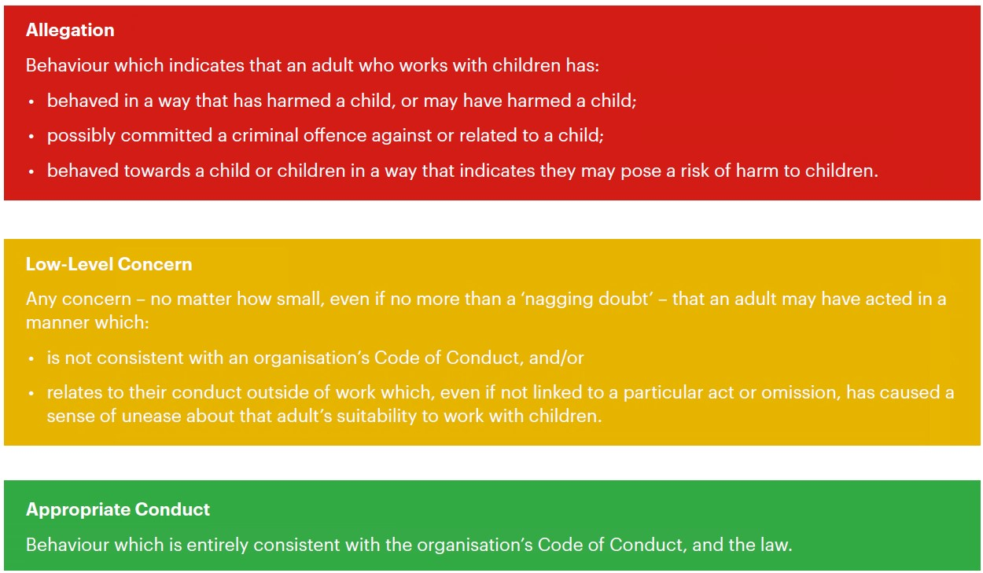

Appendix 2 Process to follow when a Low-Level Concern is raised

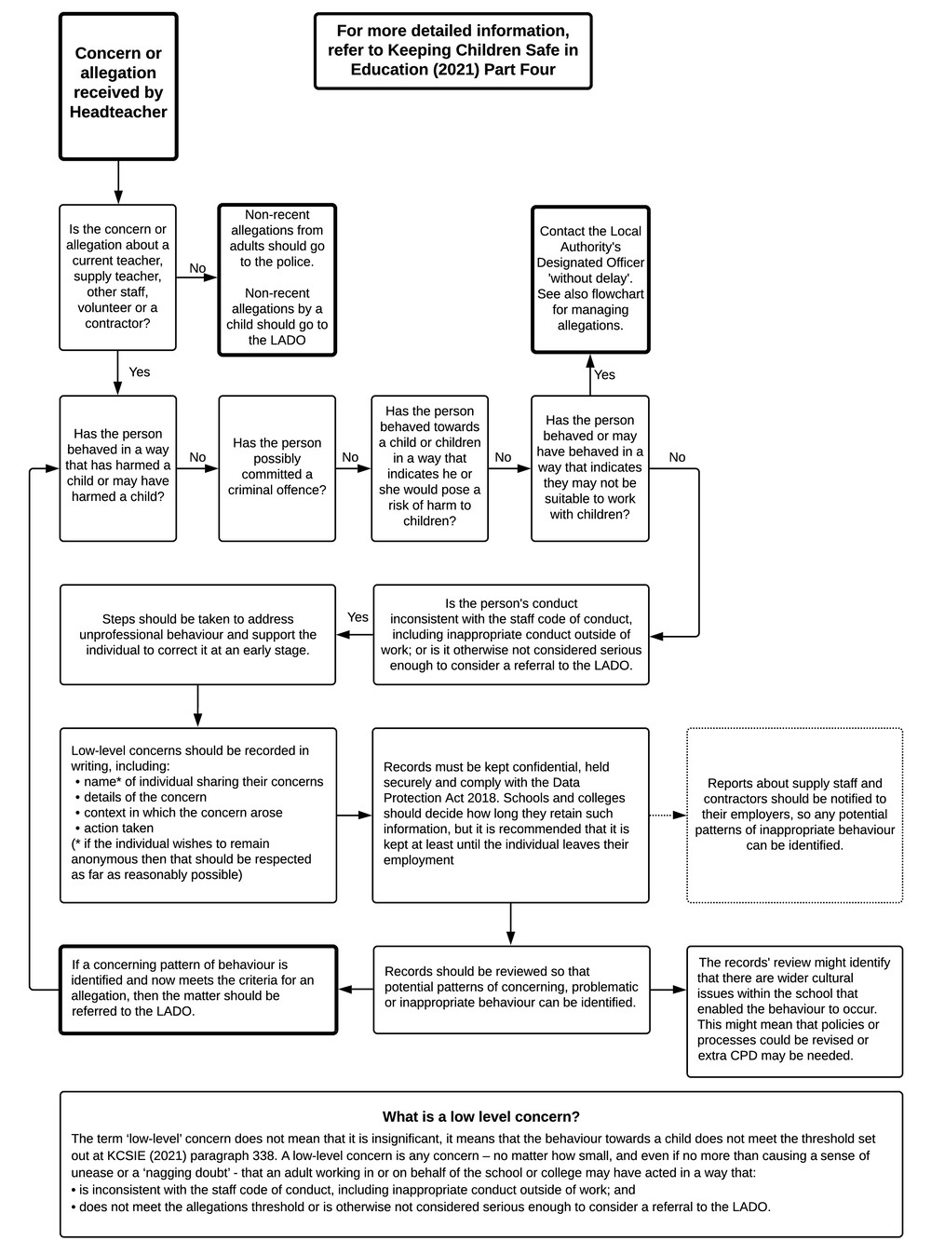

Appendix 3 Low Level Concern Form

This form will be available to staff via:
- H:\TeachersPool\Safeguarding- Lower Level Concern Form
- The Staffroom
- DSLs
- Email at the beginning of the term

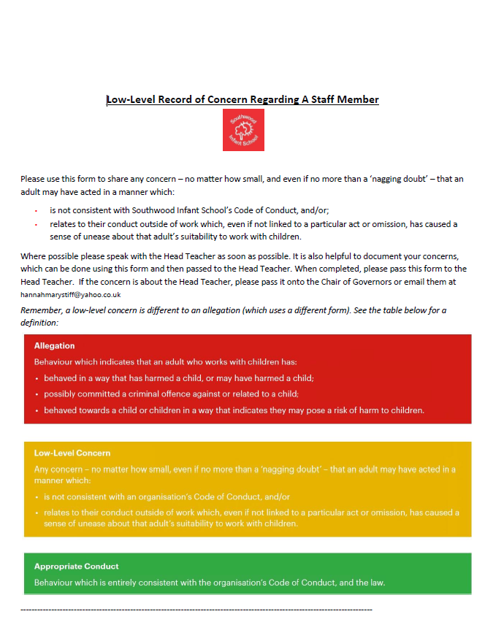

Reporting form

Name of adult writing this concern:
Name of adult whom this concern is about:
Date written:
Signature:
Please write your concerns below
You should provide a concise record – including brief context in which the low-level concern arose, and details which are chronological, and as precise and accurate as possible – of any such concern and relevant incident(s) (and please use a separate sheet if necessary). Consider any contextual information that may be appropriate to know.

The outcome of the investigation and any action taken:

Signed

Appendix 4 Key Reference Document
Read this document for further information about Low-Level Concerns, which is referenced in KCSIE 2023.
https://www.farrer.co.uk/globalassets/clients-and-sectors/safeguarding/low-level-concerns-guidance-2020.pdf

