

Excellence Enjoyment Respect
Relationships and Behaviour Policy
September 2025
Version | Date | Author | Status | Summary
2.0 | May 2017 | W. Southgate | Approved | Amended to include Physical restraint procedures by Hampshire County Council Guidelines published in 2007. Section 93
3.0 | September 2019 | W.Southgate | Approved
4.0 | September 2020 | W.Southgate | Approved
5.0 | September 2021 | Alison Padday | Approved
6.0 | November  2022 | Zoë Wisken | Approved | Changes to Behaviour Management Strategies
7.0 | September 2023 | Zoë Wisken | Approved | Few minor changes to wording
8.0 | September 2024 | Zoë Wisken | Approved | Few minor changes to wording
9.0 | September  2025 | Zoë Wisken |  | Changed policy to become more focussed on positive behaviour strategies reflective of the training the school has received form PBS.

Reviewed By: | FGB  Yearly
Date of last Review: | September 2025
Date of next Review | September 2026

Southwood Infant School
Relationships and Behaviour

Purpose
The aim of this policy is to guide teachers, children, and parents on the restorative and relationship focused behaviour management practices we implement in our school. This policy is designed to ensure a consistent and supportive approach to helping all children learn and play in a calm, nurturing, and safe environment. By promoting a calm and happy atmosphere, we aim to foster positive relationships and mutual respect among all members of our school community.

We are dedicated to creating an environment where everyone is encouraged to exhibit high standards of personal conduct and take responsibility for their actions. This commitment is reflected in our efforts to teach and reinforce appropriate behaviours in a manner that is suitable for each pupil's age and stage of development. We believe that by setting clear expectations and providing consistent support, we can help all children develop the social and emotional skills necessary for their overall well-being and success.

Our policy emphasises the importance of collaboration between teachers, children, and parents. By working together, we can create an inclusive school culture where every child feels valued and understood. We strive to ensure that our behaviour management practices are fair, transparent, and aligned with our school's core values, contributing to a positive experience for all.

Aims
- Provide a clear and consistent approach to behaviour management, by developing strong relationships and restorative practices.
- Increase self-esteem by encouraging children to set personal goals and celebrate their achievements, no matter how small.
- Provide positive feedback and support.
- Show respect and concern for others by teaching children to listen to each other and show kindness.
- Help children to develop self-control by setting clear expectations and consequences using techniques like mindfulness and self-reflection.
- Develop moral qualities through teaching lessons on honesty and truthfulness into everyday activities. The school will use stories and real-life examples to illustrate these values.
- Create a culture of openness where children feel comfortable reporting issues.
- Promote tolerance, understanding, and respect through celebrating diversity and cultural events.
- Adults will consistently ‘notice the good’ and acknowledge children' achievements using praise and rewards to reinforce good behaviour.
- For the children to feel positive about themselves and celebrate their own and other children's efforts creating a positive atmosphere where all children feel valued.
- To equip children with strategies to manage their behaviour effectively.
- Promote accountability and understanding of actions helping children to understand the impact of their actions on themselves and others, and encourage a solution-focused approach to changing future behaviours.
- Ensure that school values of Excellence Respect and Enjoyment are emphasised through the conduct of children and staff.

Objectives
All members of the school community have a responsibility to uphold these aims by:
- Respecting the rights, values and beliefs of the individual.
- Fostering and promoting good relationships and a sense of belonging to the class/school community.
- Caring for, and taking pride in the physical environment of the school.
- Offering equal opportunities and recognising the importance of different values, traditions and cultures.
- Being a `telling school’ where children are safe and bullying is not tolerated.
- Helping to develop strategies to eliminate unacceptable behaviours and applying these consistently.
- Encouraging, praising and positively reinforcing good relationships, behaviour and work.

How does our school’s ethos support positive behaviour?
At Southwood Infant School, we believe that we all have a vital role to play in promoting positive behaviour and preventing negative behaviour.
The school presents a safe and secure atmosphere in which highly effective teaching and learning can take place.
The children are encouraged to respect and care for their surroundings as well as other children and adults.
The school expects exemplary behaviour and time will be spent involving the children in discussions around our expectations in classroom and school procedures in order to encourage this.
Specifically, this will mean that our children will be taught respect:

- Respect for themselves
- Respect for others
- Respect their world

To promote positive behaviour all adults will:
- Model behaviour we want to promote through our relationships with children, parents and all members of staff.
- Endeavour to build positive relationships with all our children and see every day as an opportunity start again
- Ensure classrooms are kept well-organised and tidy.
- Celebrate and reward positive behaviour through our Learning Behaviours i.e. ‘deliberately catch people being good’
- Ensure that classes are collected from the playground on time
- Treat all children fairly (although this does not necessarily mean that all children are treated exactly the same)
- Make adaptations to support children with particular learning / SEN, social and behavioural difficulties
- Allow children to make a fresh start each lesson
- Ensure lessons are appropriately planned so that all children can access the learning
- Take time to help children reflect upon their behaviour and support children with a range of communication strategies to support positive behaviour.

Our School Values

Excellence | Respect | Enjoyment
We believe that all children deserve an excellent school where they can enjoy learning, feel safe and build positive relationships. We believe our children deserve an excellent curriculum that engages them positively and ignites a love for learning that will last a lifetime. | We believe our children should show respect for themselves, others and their wider community/ world.  We teach our children how to build positive relationships and how to maintain those relationships even when challenges occur. | We are committed to fostering a positive and inclusive environment where every child looks forward to coming to school and enjoys learning. We aim to ensure that parents feel confident and happy entrusting their children to our care, and that staff take pride in being part of our school community. We value everyone in our school and strive to create a supportive, respectful, and fulfilling environment where all stakeholders feel enjoyment.

Our School Rules
We are kind
We are gentle
We are honest
We are respectful
We try our best
We listen
We look after our property

Class rules / Class agreement
Our classroom rules are based on the Schools Rules above. Any inappropriate behaviour will always be related back to our School Rules and our class agreement. If a child breaks the rules of the classroom the process detailed below will be followed.

Staff and children share Circle time and participate in My Happy Mind sessions weekly (See PSHE Policy). These are an opportunity for sharing and respecting each other’s experiences and feelings on a variety of everyday occurrences. The children experience thisas a speaking and listening opportunity and it is a way of building confidence and self-esteem. It helps children feel comfortable about expressing their feelings as well as listening to others.

Adults in school encourage the children to speak openly about the problems they may have. A child who is prepared to tell the truth, taking responsibility for their own actions, will always receive support and encouragement from the staff.

Playground Squad

Children in Year 2 have the opportunity to become a member of the Playground Squad for half a term. These children (identified by their high visibility jackets) promote good behaviour, help others to play and have positive playtime experiences.

New children, those demonstrating vulnerability or a need to have good behaviour modelled are given a buddy to support them during playtimes.

We recognise good social and learning behaviours in a number of ways:

- Verbal comments to a class or group of pupils
- Verbal and specific praise to individual pupils
- Small privileges e.g. line up first, choose which game to warm up in PE, hand out resources
- Opportunities to share work and achievements with other pupils and staff
- Written feedback in books
- The use of stickers

Stars in the Jar
Throughout each half term the children will have the chance to work together as a class to earn stars in their jar. The stars are rewarded for excellence through working together as a team. When the class Star Jar is filled, the class will earn a class treat.

Head Teacher Awards
Each week, class teachers select one child from their class to receive the ‘Headteacher’s Award’ during our Friday Celebration Assembly. This award recognises not only academic achievements but also the demonstration of our school’s learning behaviours. During the assembly, the teacher shares the reason for the child’s selection, and the child is presented with a special Headteacher’s certificate in front of the whole school and their parents. Hearing their teacher and peers speak positively about them in this way helps to build motivation, self-belief, and self-esteem.

Lunchtime Stars
Each week a child from each class is nominated by the lunchtime supervisory staff to receive a lunchtime award for positive behaviour and super manners. They are awarded a certificate in celebration assembly and invited to eat their Friday lunch on our top table with a member of staff.

Discovery Time
Each class has an opportunity to earn 30 minutes of discovery time each week on a Friday afternoon. This is when the children are rewarded for having kept the school/class rules. During this time they choose from favourite activities while the class teacher is working with small groups of children. Discovery time is a privilege for those who have kept to our school rules, but some of the time can be lost for reflection if children have seriously broken a school rule. Children have a warning if their behaviour is not appropriate and a chance to ‘turn it around’ before time is taken away.

Understanding behaviours

Regulated and Unregulated Behaviour
At Southwood Infant School, we recognise that children may not always demonstrate our school values. In such instances, staff are trained to assess whether a child is currently able to regulate their own behaviour.
Unregulated behaviour is often a sign that a child is experiencing a heightened emotional state, commonly referred to as "fight, flight, or freeze" mode. In these moments, the child may not be in control of their actions or responses.

Dysregulated Behaviour
When a child is dysregulated, our priority is to support them in calming and regulating their emotions before addressing their behaviour. Staff focus first on helping the child feel safe and settled. Once the child is regulated, adults work to rebuild the relationship and trust, followed by a restorative conversation to reflect on the incident and find a resolution.

Guidance and prompts for these restorative conversations can be found in appendix.

Supporting Emotional Regulation: A Three-Step Approach
To help children manage their emotions and behaviour effectively, staff follow a three-step process:

- Label the Emotion
Staff begin by identifying and naming the emotion the child appears to be experiencing. This helps the child feel understood and begins the process of emotional regulation.

- Set Behavioural Boundaries
Clear and calm boundaries are established to ensure safety for all. Staff communicate expectations in a supportive manner, helping the child understand which behaviours are acceptable.

- Supporting full engagement of the HAP team.
When children are dysregulated, their brain’s amygdala becomes highly active, making it difficult for them to access the areas responsible for decision-making, empathy, and problem-solving. This is often referred to as "flipping the lid." Staff support children “wake up" the Hippocampus and Prefrontal Cortex to re-engaging the thinking part of the brain before addressing behaviour.

Relate
Before moving into the restorative stage, it is essential for the adult to reconnect with the child and re-establish a sense of trust and emotional safety. This relational approach helps the child feel secure and ready to engage in meaningful reflection.

Restore
Once the child is regulated and the relationship has been re-established, staff will facilitate a restorative conversation.

Restorative conversations are tailored to the child’s age, developmental stage, and any additional needs. The key reflective questions include:

How were you feeling?
What happened?
How can we put it right?
What needs to happen next time?

Regulated Behaviour
There are times when children, although regulated, make choices that do not align with our school values. In such cases, a stepped approach to consequences is followed. The focus remains on helping the child understand the impact of their actions, learn from the experience, and make better choices in the future.
At Stage 4, a scripted intervention will be used to ensure consistency and clarity in communication.

Stepped Sanctions

 | Stepped Sanctions
1 | General check in to create awareness
2 | Reminder – The child will be specifically addressed and a reminder of the expectations will be made. Is there a need that needs to be considered?
3 | Thinking time - a chance to reset
4 | Final warning to turn it around – scripted intervention used
5 | Restorative action or sanction using the reflection pack at break time
6 | Restorative conversation.

In very serious cases Step 7 and 8
7 Withdrawn from lesson
If a child has already had restorative conversations and is continuing to not demonstrate our school values, they will go to the Assistant Headteacher where they will have to remain for the duration of the lesson, completing the required work. This will automatically mean that they will miss their usual break time with the class. A log of children sent will be monitored by the SLT at the end of each half term.

8 Sent to Assistant Headteacher, SENCo or Headteacher
For serious and or persistently disruptive behaviour, children may be sent directly to any one of the members of the Senior Leadership above who will decide on the consequence proportionate to the behaviour. Formal contact may be sought with parents.
If unacceptable behaviour still continues, a meeting between Headteacher, parent and child‘s teacher will be arranged to discuss remedies and/or to invite outside intervention (behaviour support team). An IBP (Individual Behaviour Plan) will be put into place with all parties agreeing to the steps, rewards and sanctions set out in the plan.
In the event of a child’s behaviour deteriorating to such an extent that he/she is a danger to himself/herself, other children or adults, the County Exclusion Guidelines will be followed.
.

Within the classroom there will be a visual chart where it will be indicated which step the child has reached.

 |  |  | Reflection

Thinking Time
Thinking Time offers children a chance to pause, reflect, and reset their behaviour in a calm and structured way.
For most children, this will last approximately 3 – 5 minutes, the duration may be adjusted to suit the child’s age and developmental stage. Children should be given a timer and directed to sit in a designated area either within the classroom or just outside where they can reflect quietly and safely.
Once the timer ends, the adult will clearly explain the next steps. The child is then supported in re-joining the class and continuing with their learning.
Scripted Intervention

When a child’s behaviour does not align with our school values, staff may use a calm, consistent, and structured script to address the behaviour. This approach helps maintain emotional safety and clarity for the child. The script includes:

“I have noticed that…”
“You are not showing… (insert school value)”
“You need to…”
“This is your final warning.”
“Thank you.”

Restorative Actions and Sanctions
The primary aim of restorative actions is to support positive behaviour change and help children understand the impact of their actions on others. These actions encourage children to take responsibility, make amends, and reflect on how they can contribute positively to our school community.

Restorative practices are designed to promote personal growth, accountability, and a stronger sense of belonging within the school.

Working through the stepped sanctions

In general, children will work through the 6 stages. If a pupil is aggressive, threatens or hurts another pupil or
a member of staff, they will move straight to Stage 5.

Missing part of a break time for restorative actions
Missing part of a break time may be used as a restorative measure to help children reflect on their behaviour and understand its impact. This time should be purposeful and supportive, allowing the child to engage in a meaningful activity that promotes personal growth.

During this time, children might complete a restorative task such as writing a letter of apology, repairing something that was damaged, or participating in an activity designed to help them develop strategies for managing emotions such as exploring alternative responses when feeling angry.

Children with Behaviour or Additional Needs – inclusive support
As an inclusive school, we recognise that some children may require personalised strategies and additional support to consistently demonstrate our school values.
Staff adapt their language and approach to suit each child’s age, developmental stage, and individual needs. For pupils who experience ongoing difficulties in managing their emotions and behaviour, an Individual Behaviour Plan (IBP) may be developed to provide tailored support.
Parents are actively involved in creating and reviewing these plans, and where appropriate, external agencies may be consulted to offer further guidance and expertise. This may include services such as the Primary Behaviour Service (PBS) and the Educational Psychology Service.

When required ELSA support will be used to address the emotional and social difficulties underlying and resulting from this behaviour.

Exclusion and suspensions
Exclusion or suspension is used only in the rare instances where a child is either not responding at all to a range of behaviour management strategies and their behaviour is significantly and repeatedly disrupting the learning of others or if the child has behaved in a way deemed as particularly extreme, such as being violent towards another pupil or member of staff, or has used foul or abusive language towards any member of staff. The school will follow the LA guidelines on this.

- Suspension refers to the temporary removal of a pupil from school.
- Permanent exclusion means the pupil is no longer allowed to attend the school or enter the school premises.

If your child is suspended or permanently excluded, the Headteacher (or their nominated representative) will inform you immediately. This may be done via a phone call or by inviting you to a meeting. During this conversation, you will be informed of the reason for the decision, the length of the suspension (if applicable), and any next steps.

If your child has a social worker or is looked after, their social worker will also be notified without delay.

If your child is suspended, your support plays a vital role in helping them return to school positively. The school will provide work for your child to complete at home during the first five days of the suspension. It is your responsibility to ensure this work is completed and returned to school for marking.

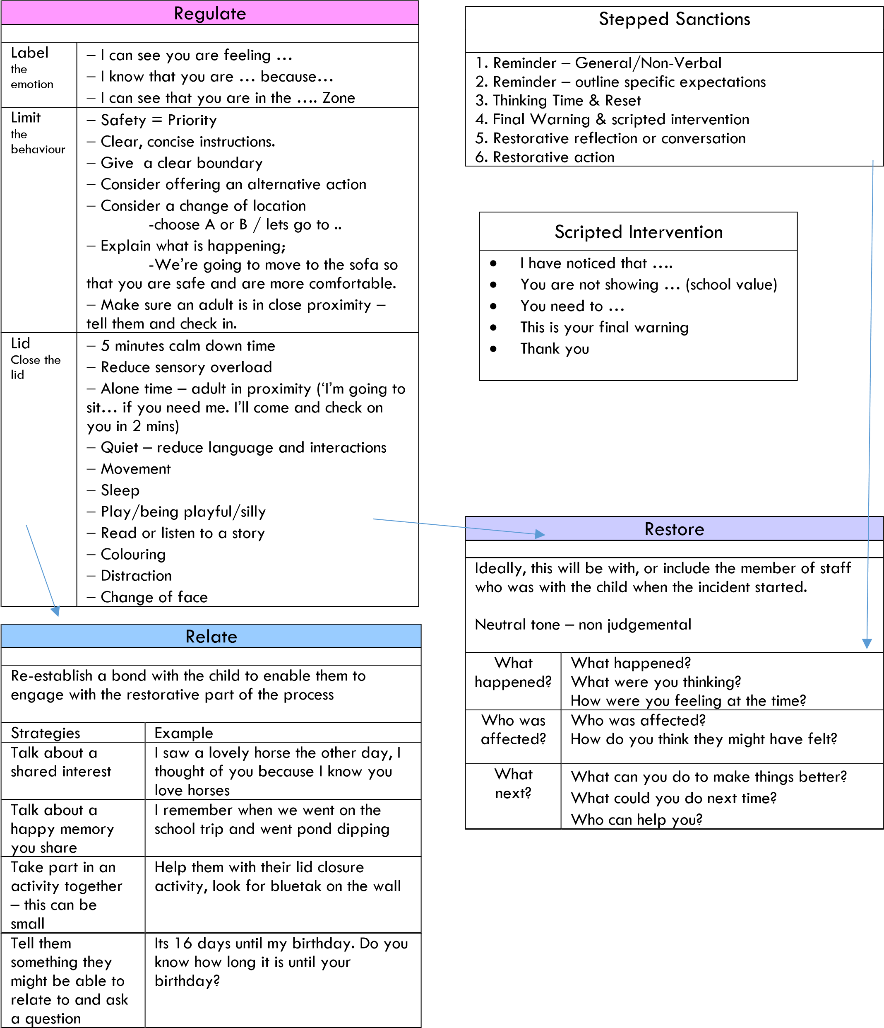

Children’ conduct outside the school gates
For non-criminal bad behaviour and bullying which occurs off the school premises and which is witnessed by a staff member or reported to the school, teachers may discipline children for misbehaviour when a child is:
- taking part in any school-organised or school-related activity or
- travelling to or from school or
- wearing school uniform or in some other way identifiable as a pupil at the school
- or misbehaviour at any time, whether or not the conditions above apply, that:
- Could have repercussions for the orderly running of the school or poses a threat to another pupil or member of the public or could adversely affect the reputation of the school.

Sanctions will be proportionate to the behaviour and will follow the school’s list of sanctions above.

Power to use reasonable force
Members of staff have the power to use reasonable force to prevent children committing an offence, injuring themselves or others, or damaging property, and to maintain good order and discipline in the classroom. This should always be used as a last resort and the level of force required is proportionate to the situation – no more force than is needed. Examples include:
Using force to control - this may involve passive physical contact, such as standing between children or blocking a pupil’s path, or active physical contact such as leading a pupil by the arm out of a classroom. We closely follow DFE guidance that refers to the Education Acts of 1996 and 2002 and to Section 93 of the Education and Inspections Act 2006. We also follow Hampshire County Council Guidelines published in 2007. Section 93 provides the legal power for all school staff to use reasonable force should this be necessary. Please refer to our Restrictive Physical Intervention Policy for further information.

Using force to restrain - this may involve holding a pupil back physically or bringing a pupil under control. It would typically be used in more extreme circumstances, for example when a pupil is trying to hurt another.

Schools can use reasonable force to:
- remove disruptive children from the classroom where they have refused to follow an instruction to do so;
- prevent a pupil behaving in a way that disrupts a school event or a school trip or visit;
- prevent a pupil leaving the classroom where allowing the pupil to leave would risk their safety or lead to behaviour that disrupts the behaviour of others;
- prevent a pupil from attacking a member of staff or another pupil, or to stop a fight in the playground; and
- restrain a pupil at risk of harming themselves through physical outbursts.
Where the Headteacher believes that physical restraint may be needed in dealing with a particular child, parents are involved closely to ensure they understand and accept the actions to be taken.
If a child should attempt to leave the school premises, staff will keep the child in sight and encourage them to return to the school property. Physical restraint will be used where the child’s safety is at risk and minimal physical restraint may also be considered in order to walk the child back to school property. Parents will be telephoned immediately and the police informed.

Our policy at Southwood Infant School is to encourage staff to avoid the use of force wherever possible. Where it is not possible to avoid its use, then the response should be directly responsive to the situation. If children need to be removed from a lesson for being disruptive and will not willingly do so, then a member of the Senior SLT should be called to perform this task. The school follows the guidance and approaches stated in our restrictive intervention policy.
As a school, we recognise our legal duty to make reasonable adjustments for disabled children and children with special educational needs (SEN) when using reasonable force.

In any circumstance where reasonable force has been used, parents will always be notified. Where appropriate, further external agency support for the child may be explored.
All ‘significant incidents’ where force has been used will be recorded by the school.
All complaints about the use of force will be thoroughly, speedily and appropriately investigated.

Where a member of staff has acted within the law – that is, they have used reasonable force in order to prevent injury, damage to property or disorder, no further action will be taken. In all other cases, the school’s disciplinary policy will be followed exactly.
The school recognises its duty of care towards its employees. Appropriate pastoral care and advice will be given to any member of staff who is subject to a formal allegation following a use of force incident.

Responsibilities for Promoting Positive Behaviour

As a whole school, we aim to promote positive behaviour and eliminate instances of poor behaviour by:

Senior Leadership Team
- Taking a lead in establishing and maintaining a positive school ethos.
- Monitoring and reviewing behaviour throughout the school.
- Monitoring attendance and punctuality and responding immediately when either is poor.
- Recording and reporting incidents of serious misconduct (Behaviour file in Headteacher’s room).
- Ensuring that the buildings and grounds are well maintained.
- Through referrals to the Primary Behavioural Service.
- The use of Whole School Assemblies to raise awareness of behaviour and bullying issues and provide a whole school focus for anti-bullying.
- Induction for all new staff and annual whole school review of procedures.
- Training staff so they can better identify and help vulnerable children and those who may be more at risk of bullying.
- Organising assertiveness training from ELSA for children experiencing recurring problems. This aims to change the behaviour of vulnerable children to help them use verbal and body language in a way that discourages bullying, including how to respond to bullying in a calm, controlled manner. This can include how to make assertive statements, deal with name-calling, getting help from bystanders etc.
- Supporting staff in the practical application of this policy and procedures.

Staff
- By providing a stimulating and challenging learning environment, which enables all children to achieve the highest possible standards.
- Being constantly aware of the needs of individual children and their relationships with others.
- Enabling children to take increasing responsibility for their own learning and conduct, intervening where necessary.
- Being a good role model - punctual, well prepared, organised and a cooperative team player.
- Providing opportunities for children to discuss appropriate behaviours, working together, reflecting a shared philosophy and practice together.
- Looking for every opportunity to praise and highlight children’ achievements both academic and social.
- Enforcing the agreed behaviour code consistently.
- By being vigilant for signs of bullying.
- Always taking reports of bullying seriously and investigating them thoroughly
- Use the curriculum to increase children’s awareness of bullying and to help them develop strategies to combat it.
- Use circle time to explore issues and give opportunities to discuss feelings.
- Observe children’ play patterns and relationships – note children who appear isolated or unhappy and find out why.
- Use SMSC to teach skills and strategies to deal with poor behaviour and bullying.
- Encourage targets and witnesses of any poor behaviour or bullying to report incidents
- Bring cases of bullying out into the open, so that children know what has taken place and how it has been dealt with.
- Demonstrate, through our procedures, that no case of bullying is considered too trivial to warrant attention.
- Take appropriate action, or refer behaviour matters to a Team Leader, Assistant Headteacher or Headteacher for further action.
- Record either behaviour or bullying incidents on the appropriate proforma and retain these records for discussion at Leadership Meetings or for school monitoring purposes.
- Inform parents at an early stage of any known incidents of bullying for all children involved.
- Follow up any incidents within two weeks and again after half a term to ensure that there is no reoccurrence.

Children
- Attending school regularly and punctually.
- Being organised-bringing necessary kit, taking letters home promptly, returning homework, having home/school book available, ready to begin lessons on time.
- Contributing to the development of the school’s behaviour code of conduct.
- Conducting themselves in an orderly manner in line with the code of conduct.
- Take growing responsibility for their environment and their own learning and conduct.
- Being aware that we are a ‘telling’ school – this means that it is the duty of any bystanders to report any incidents and they will not be accused of telling tales.
- Telling any child with poor behaviour to stop – State quite clearly that the behaviour is unwelcome and offensive and, if possible, walk away from the situation.
- Seeking adult help – if the bad behaviour or bullying continues or if they are afraid to tell the bully to stop.
- Reporting incidents to their class teacher or any member of staff – children must feel confident that any incident can be resolved satisfactorily. They should keep a record of the date and time of any offensive electronic messages and let an adult see them.
- Becoming Play Leaders to organise games and activities.

Parents
Parents have a clear role in making sure that their child is well behaved at school. Schools are required to have, and to ask parents to sign and uphold, a Home School Agreement that outlines the responsibilities of the parents or carers, the children and the school, including those relating to behaviour.
- Ensure children attend school in good health, punctually and daily (this involves taking holidays outside term time whenever possible).
- Provide prompt explanation of all absences through a note or telephone call to the school office.
- Provide support for discipline within the school.
- Inform us of concerns so that we can work together to make our children’s school experience as happy as possible. In matters of discipline, the school will expect to work in close cooperation with parents.
- Contact the class teacher in the first instance if they have any concerns about their child or the behaviour of other children. They may also make an appointment to see a senior member of staff or the Head teacher is they wish.
- Inform us as soon as possible after an incident occurs, particularly given that younger children’s memories are very short.

Record Keeping
The school has various proforma to record incidents:
- LTSAs – individual booklets to record any poor behaviour and share with the Class teacher – record actions.
- Class teachers – CPOMS is used for any serious or persistent misbehaviour
- Class teachers will keep a log of the reflections that they have completed.
- Leadership – half termly summary sheets of any unwanted behaviour across school are analysed
- All staff – Bullying recording on CPOMS
- Head teacher – overviews of all reported behaviour and bullying CPOMs
- IEP’S for behaviour
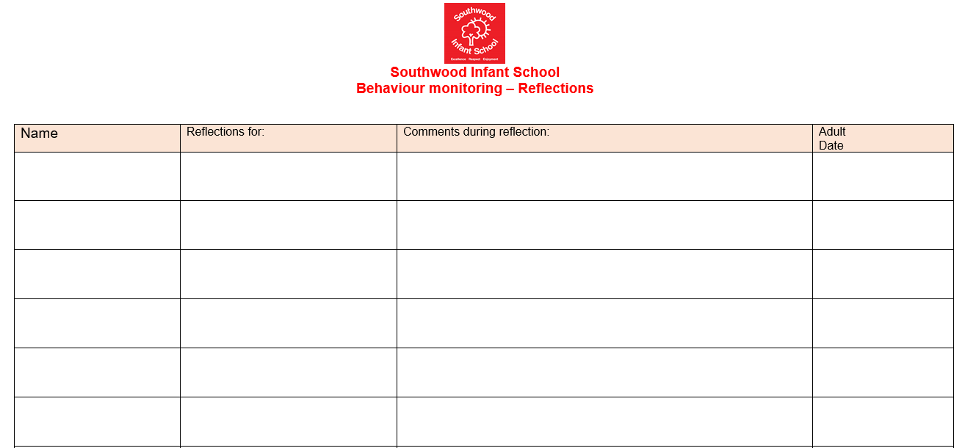
Procedures
To ensure the involvement of all members of the school community in this policy:
- Any ongoing behaviour issues will be discussed regularly in weekly staff meetings.
- Regular meetings will be held between Lunchtime Supervisors and the assistant Head teacher or Head teacher.
- The school will conduct an annual pupil questionnaire. The results will be analysed and used to inform future amendments to policy and/or practice.
- Teacher’s behaviour logs will be monitored each term by the SLT.
- Assistant Head teacher log will be monitored each term by the SLT any patterns in behaviour will be discussed and actions will be put in place to support the child.
- The Headteacher will regularly report to the Governors about behaviour and bullying.
- A copy of this policy will emailed to all staff and kept in the policy folder on the shared drive.
- Parents will have access to this policy via the school website.
- Behaviour Policy will be available via our website. It will also be distributed to new parents each year.

