

Excellence Respect Enjoyment

HOME SCHOOL AGREEMENT
2025-2026

Headteacher | Mrs Zoë Wisken
Chair of Governors | To be confirmed

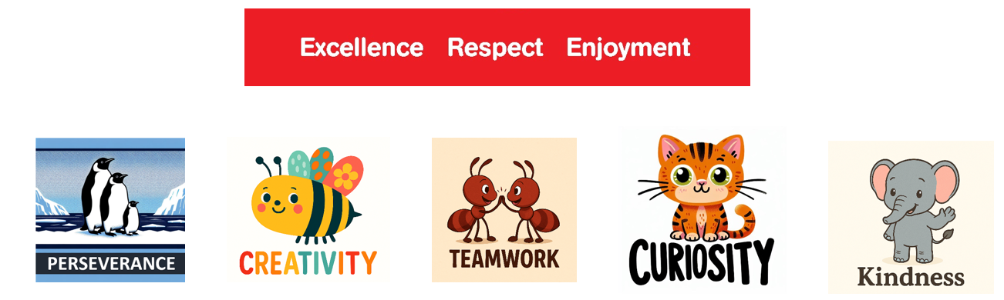

At Southwood Infant School we will aim to:

- Value each child as an individual and celebrate their small and big achievements to nurture their confidence.
- Foster a love of learning by encouraging curiosity, creativity, and wonder in their early learning experiences.
- Educate the whole child, supporting their emotional, social, and academic growth to help them become kind, independent, and responsible individuals.
- Set realistic yet high expectations for learning and behaviour, with gentle guidance that helps children thrive.
- Develop positive relationships that form the foundation for effective behaviour management, creating a sense of belonging and security for every child.
- Provide a stimulating curriculum enriched with hands-on activities, imaginative play, and engaging topics that excite young learners and encourage exploration.
- Nurture resilience, enthusiasm, and positivity in children, helping them approach challenges with confidence and determination.
- Create a warm, safe, and joyful environment where children feel happy, valued, and part of a caring community.
- Work closely with parents, recognising their vital role and encouraging partnership in their child's educational journey.
- Prioritise each child’s mental well-being by teaching strategies for maintaining emotional health and coping with life’s challenges.

Everyone at Southwood Infant School follows Our Southwood Rules

We are Kind and Gentle
We think about how we treat ourselves and others
We do not hurt others physically or with our words..

We are respectful
We respect ourselves and others

We are honest
We always tell the truth.
We try our best
We are resilient and always try our best.
We listen
We do as we are asked the first time.
We look after property
We take care of our school environment and the world we live in.

As a whole school and as individual staff we aim to:
- Prioritise your child’s safety and happiness.
- Offer a broad, balanced curriculum tailored to meet each child’s needs.
- Set clear goals and provide high-quality teaching that is engaging, relevant, and challenging.
- Value every child individually and encourage them to reach their full potential.
- Maintain high standards of learning and behaviour by creating positive relationships and a sense of responsibility.
- Create opportunities for children to continue their learning beyond the classroom.
- Always be open and welcoming, encouraging involvement in the school’s daily life.
- Address any concerns or issues affecting your child’s work or behaviour.
- Keep you updated on your child’s progress throughout the year.
- Share information about school activities through frequent communications.
- Ensure you’re informed about the school’s policies and behaviour guidelines.
- Maintain strong home-school communication via newsletters, Arbor, emails, and the school website.
As a family, we aim to:
- Ensure that our child attends school, is on time and also is properly equipped.
- Explain all absences from school.
- Let the school know of any concerns or problems that might affect our child’s work or behaviour.
- Support our child with his/her homework and other opportunities for home and remote learning, as appropriate.
- Encourage good behaviour, politeness and respect for others and their property, by fully supporting the School Behaviour Policy.
- Encourage our child to be involved in all aspects of school life.
- Attend parent consultation evenings and discussions about our child’s progress
- Encourage and celebrate our child’s achievements.
- Book our family holidays within the school’s 190 days school holidays
- Ensure the schools data protection and social media policies are followed.
- Ensure that my child dresses in the correct uniform including small red/white hair accessories and appropriate school shoes and plimsolls/trainers for PE ·
- Ensure that my child has an appropriate hairstyle (e.g. no mohicans, fashion shaving, decretive holiday hair wraps) and ensure long hair is tied back.
- Regularly check my child’s hair for headlice.
- Ensure all nail varnish and tattoos/transfers are removed after weekends and holidays.
- Ensure that my child wears stud earrings only in each ear.
- Read all letters/messages/emails that are sent home.
- Inform the school immediately of any changes to parents/carer and emergency contacts details.
- Follow guidance from the school and will not send my child to school if they are unwell.

As a child at Southwood Infant School I will:
- Work as hard as I can and take pride in my work at school and at home.
- Get ready and come to school on time.
- Follow the Southwood Rules
- Be kind and helpful to others at all times.
- Listen to teachers and others.
- Tell a grown-up if I am upset or unhappy.
- Wear the school uniform and be tidy in my appearance.
- Take responsibility for my actions.
- Care for the school environment and help to keep it clean and tidy.
- Take an active part in the school community and contribute to school life.

Signed:
Parent / Carer…………………………………………………… Date…………..…

Child……………………………………………………………… Date…………..…

Headteacher 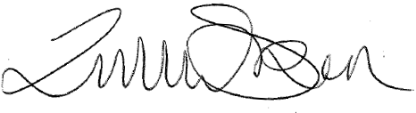 Date…………..…

