

Maths
Calculation policy
January 2025

Version | Date | Author | Status | Summary
1.0 | January 2025 | P.Kinsella | Approved | Updated policy

Date of Review: January 2027

Addition Year 1
Selected National Curriculum Programme of Study Statements Pupils should be taught to:  - represent and use number bonds and related subtraction facts within 20.  - add and subtract 1-digit and 2-digit numbers to 20, including 0. |  | The Big Ideas (NCTEM)  Relating numbers to 5 and 10 helps develop knowledge of the number bonds within 20. For example, given 8 + 7, thinking of 7 as 2 + 5 and adding the 2 to 8 to make 10 and then the 5 to total 15.  Thinking of part whole relationships is helpful in linking addition and subtraction. For example, where the whole is 6, and 4 and 2 are parts. This means that 4 and 2 together form the whole, which is 6 and 6 subtract 4 leaves the 2 and 6 subtract 2 leaves the 4.
Stage 1 | Stage 2 |  | End of Year Expectation
Represent number bonds within 10.  4 + 6 = 10  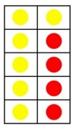  ‘Contains material developed by NCETM and licensed under Open Government Licence v3.0’ http://www.nationalarchives.gov.uk/doc/open-government-licence/version/3/  Find 1 more from any given number within 20.  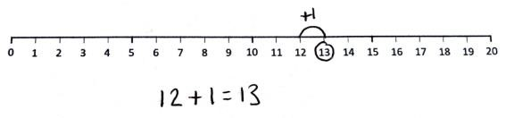 | Use number bonds within 10.  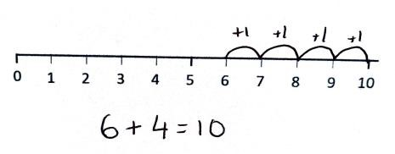  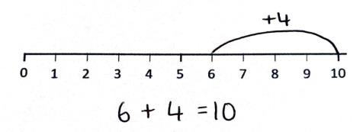  Find 1 more from any given number within 50.  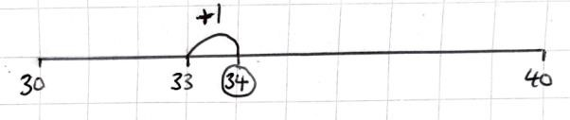 |  | Represent and use number bonds within 20.  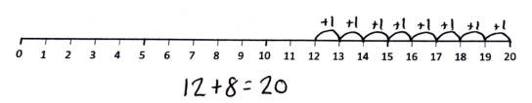  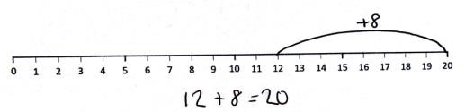  Find 1 more from any given number within 100.  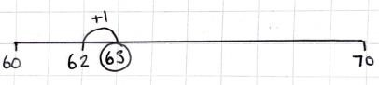  Add 1-digit and 2-digit numbers to 20.  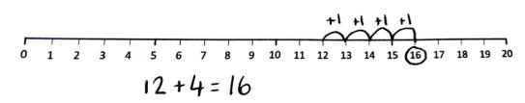

Addition Year 2
Selected National Curriculum Programme of Study Statements Pupils should be taught to:  - recall and use addition and subtraction facts to 20 fluently and derive and use related facts up to 100.  - add and subtract numbers using concrete objects, pictorial representations, and mentally, including:  o a 2-digit number and ones o a 2-digit number and tens o two 2-digit numbers o adding three 1-digit numbers |  | The Big Ideas (NCETM)  Understanding that addition of two or more numbers can be done in any order is important to support children’s fluency. When adding two numbers it can be more efficient to put the larger number first. For example, given 3 + 8 it is easier to calculate 8 + 3. When adding three or more numbers it is helpful to look for pairs of numbers that are easy to add. For example, given 5 + 8 + 2 it is easier to add 8 + 2 first than to begin with 5 + 8. Understanding the importance of the equals sign meaning ‘equivalent to’ (i.e. that 6 + 4 = 10, 10 = 6 + 4 and 5 + 5 = 6 + 4 are all valid uses of the equals sign) is crucial for later work in algebra. Empty box problems can support the development of this key idea. Correct use of the equals sign should be reinforced at all times. Altering where the equals sign is placed develops fluency and flexibility.
Stage 1 | Stage 2 |  | End of Year Expectation
Add 2-digit numbers and ones to 50 without bridging.  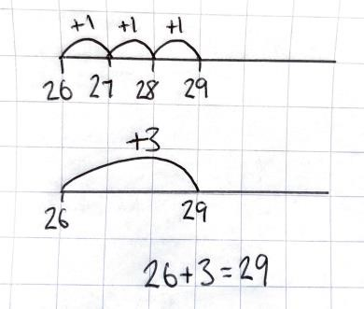  Add 2-digit numbers and ones to 50 with bridging.  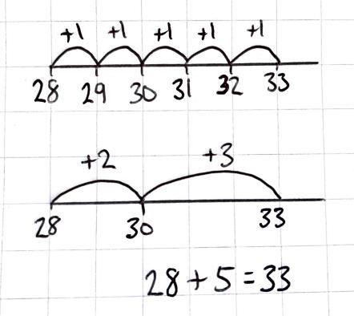 | Add 2-digit numbers and ones to 100 without bridging.  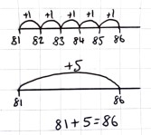  Add 2-digit numbers and ones to 100 with bridging.  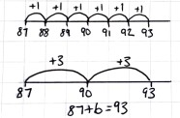  Add 2-digit and tens.  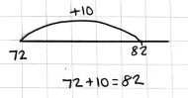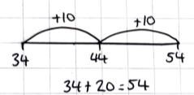  Adding three 1-digit numbers.  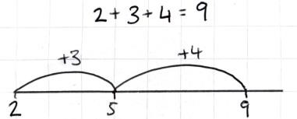 |  | Adding two 2-digit numbers without bridging.  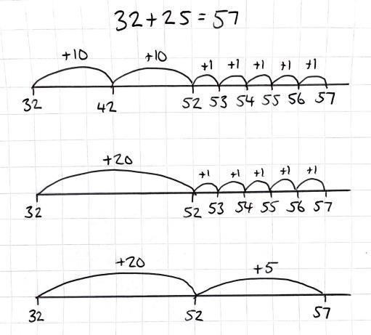  Adding two 2-digit numbers with bridging.  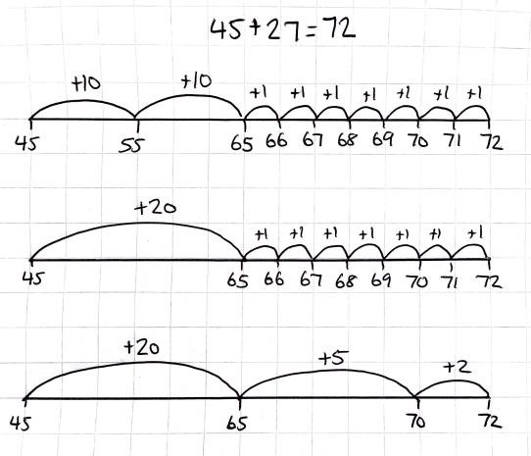

Subtraction Year 1
Selected National Curriculum Programme of Study Statements Pupils should be taught to:  - represent and use number bonds and related subtraction facts within 20  - add and subtract 1-digit and 2-digit numbers to 20, including 0 |  | The Big Ideas (NCTEM)  Relating numbers to 5 and 10 helps develop knowledge of the number bonds within 20. For example, given 8 + 7, thinking of 7 as 2 + 5 and adding the 2 to 8 to make 10 and then the 5 to total 15  Thinking of part whole relationships is helpful in linking addition and subtraction. For example, where the whole is 6, and 4 and 2 are parts. This means that 4 and 2 together form the whole, which is 6 and 6 subtract 4 leaves the 2 and 6 subtract 2 leaves the 4.
Stage 1 | Stage 2 |  | End of Year Expectation
Represent number bonds within 10.  10 – 6 = 4  ‘Contains material developed by NCETM and licensed under Open Government Licence v3.0’ http://www.nationalarchives.gov.uk/doc/open-government-licence/version/3/  Find 1 less from any given number within 20.  .  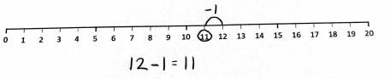 | Use number bonds within 10.  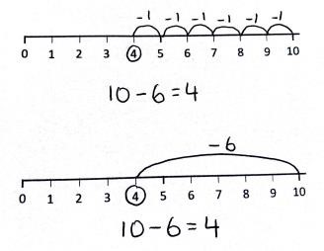  Find 1 less from any given number within 50.  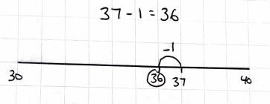 |  | Represent and use number bonds within 20.  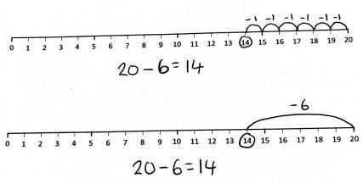  Find 1 less from any given number within 100.  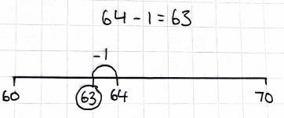  Subtract 1-digit and 2-digit numbers within 20.  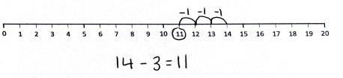

Subtraction Year 2
Selected National Curriculum Programme of Study Statements Pupils should be taught to:  - recall and use addition and subtraction facts to 20 fluently, and derive and use related facts up to 100  - add and subtract numbers using concrete objects, pictorial representations, and mentally, including:  - a 2-digit number and ones o a 2-digit number and tens o two 2-digit numbers  - adding three 1-digit numbers  - show that addition of two numbers can be done in any order (commutative) and subtraction of one number from another cannot |  | The Big Ideas (NCETM)  Understanding that addition of two or more numbers can be done in any order is important to support children’s fluency. When adding two numbers it can be more efficient to put the larger number first. For example, given 3 + 8 it is easier to calculate 8 + 3. When adding three or more numbers it is helpful to look for pairs of numbers that are easy to add. For example, given 5 + 8 + 2 it is easier to add 8 + 2 first than to begin with 5 + 8. Understanding the importance of the equals sign meaning ‘equivalent to’ (i.e. that 6 + 4 = 10, 10 = 6 + 4 and 5 + 5 = 6 + 4 are all valid uses of the equals sign) is crucial for later work in algebra. Empty box problems can support the development of this key idea. Correct use of the equals sign should be reinforced at all times. Altering where the equals sign is placed develops fluency and flexibility.
Stage 1 | Stage 2 |  | End of Year Expectation
Subtract 2-digit numbers and ones with numbers to 50 without bridging.  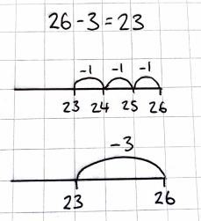  Subtract 2-digit numbers and ones to 50 with bridging.  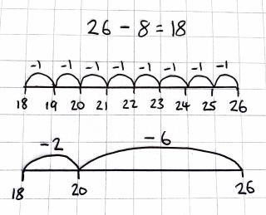 | Subtract 2-digit numbers and ones to 100 without bridging.  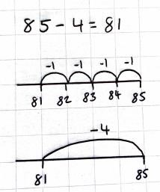  Subtract 2-digit numbers and ones to 100 with bridging.  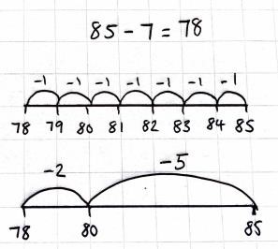  Subtract 2-digit numbers and tens.  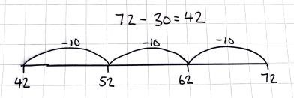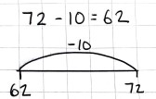 |  | Subtract two 2-digit numbers without bridging.  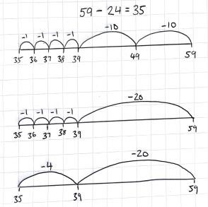  Subtract two 2-digit numbers with bridging.  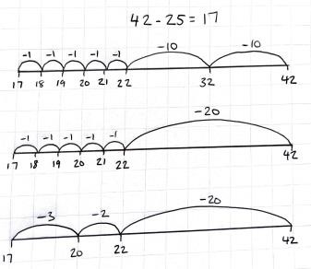

Multiplication Year 1
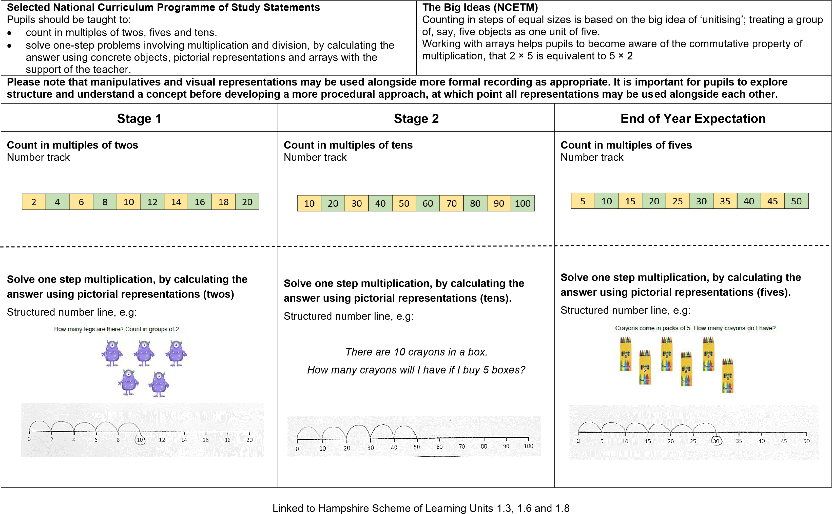
Multiplication Year 2
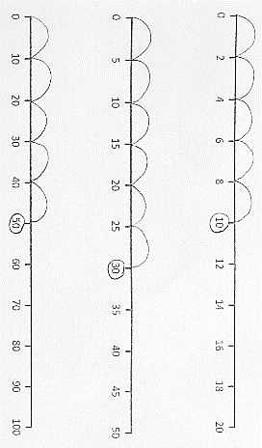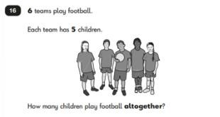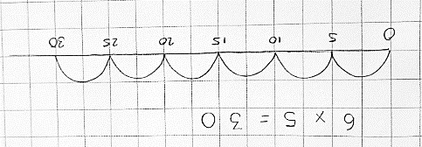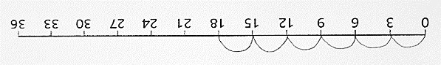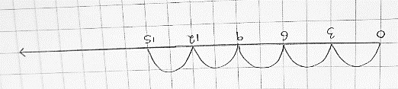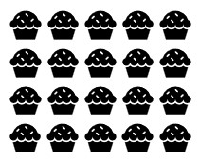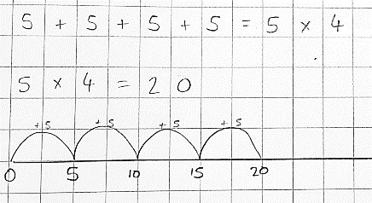
Selected National Curriculum Programme of Study Statements

Pupils should be taught to:

•

count in steps of two, three, and five from 0, and in tens from any number, forward
and backward.

•

recall and use multiplication and division facts for the 2, 5 and
multiplication
10
tables, including recognising odd and even numbers.

•

s
olve problems involving multiplication and division, using materials, arrays,
repeated addition, mental methods, and multiplication and division facts, including
problems in context
.

The Big Idea
NCETM
(
)

It is important that pupils both commit multiplication facts to memory and also develop
an understanding of conceptual relationships. This will aid them in using known facts
to work out unknown facts and in solving problems.

Pupils should look for and recognise patterns within tables and connections between
them (e.g. 5× is half of 10×).

Pupils should recognise multiplication and division as inverse operations and use this
knowledge to solve problems. They should also recognise division as both grouping
and sharing.

Please note that manipulatives and visual representations may be use
d

alongside more formal recording as appropriate. It is important for pupils to explore
structure and understand a concept before developing a more procedural approach, at which point all representations may be us
ed alongside each other.

Stage 1

Stage 2

End of Year Expectation

Count in
steps of
two, five from 0 and in tens from
any number, forward and backward.

Structured number line
.

Count in
steps of
3.

Number track

Solve problems

involving multiplication using
repeated addition.

Unstructured number line
, e.g

How many muffins are there altogether?

C
ount
i
n
steps of
3
.

Structured number line
, e.g.

Tilly ran 3 miles every day.

How many miles has she run after 6 days?

R
ecall
and use multiplication facts for the
5
2
,

and

10
multiplication tables.

Unstructured number line to ‘prove it’

‘Contains KS
1

SATs materials licensed under Open Government Licence v3.0

Open Government Licence (nationalarchives.gov.uk
)

Count in
steps of 3.

Unstructured number line

Linked to Hampshire Scheme of Learning Units
2.3
, 2.6 and
2.10

Division Year 1
Selected National Curriculum Programme of Study Statements Pupils should be taught to:  - count in multiples of twos, fives and tens.  - solve one-step problems involving multiplication and division, by calculating the answer using concrete objects, pictorial representations and arrays with the support of the teacher. |  | The Big Ideas (NCETM)  Counting in steps of equal sizes is based on the big idea of ‘unitising’; treating a group of, say, five objects as one unit of five.  Working with arrays helps pupils to become aware of the commutative property of multiplication, that 2 × 5 is equivalent to 5 × 2
Please note that manipulatives and visual representations may be used alongside more formal recording as appropriate. It is important for pupils to explore structure and understand a concept before developing a more procedural approach, at which point all representations may be used alongside each other.
Stage 1 | Stage 2 |  | End of Year Expectation
Making equal groups – sharing.  Concrete objects and pictorial representations, e.g:  I have 12 sweets and share them between myself and a friend (2 people), how many will we each have?  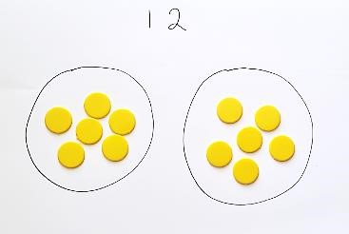  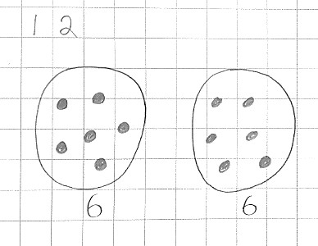  “If I share 12 equally between 2 groups, there will be 6 in each group.” | Making equal groups – grouping.  Concrete objects and pictorial representations, e.g:  I have 12 cookies to put in bags.  If I put 2 in each bag how many bags will I need?  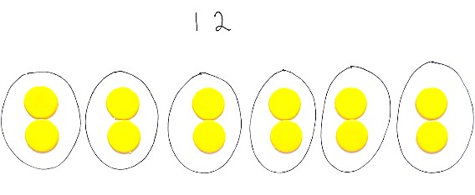  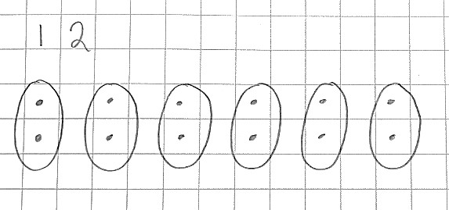  “There are 12 altogether. There are 6 equal groups of 2.” |  | Making equal groups (including finding half of a quantity).  Bar models, e.g:  I had 12 grapes and I ate half. How many are left?  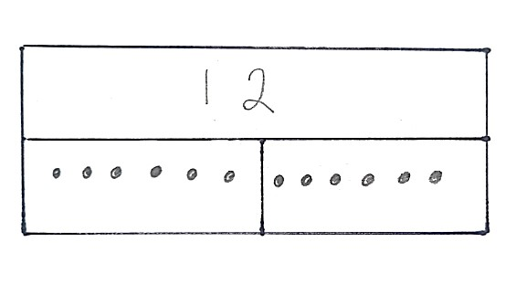  “There are 12 altogether. They are shared into 2 equal groups. There are 6 in each group. Each group is half of the whole. I know that there are 6 grapes left.”

Division Year 2
Selected National Curriculum Programme of Study Statements Pupils should be taught to:  - count in steps of two, three, and five from 0, and in tens from any number, forward and backward.  - recall and use multiplication and division facts for the 2, 5 and 10 multiplication tables, including recognising odd and even numbers.  - show that multiplication of two numbers can be done in any order (commutative) and division of one number by another cannot.  - solve problems involving division, using materials, arrays, repeated addition, mental methods, and multiplication and division facts, including problems in contexts. |  | The Big Idea (NCETM)  It is important that pupils both commit multiplication facts to memory and also develop an understanding of conceptual relationships. This will aid them in using known facts to work out unknown facts and in solving problems.  Pupils should look for and recognise patterns within tables and connections between them (e.g. 5× is half of 10×).  Pupils should recognise multiplication and division as inverse operations and use this knowledge to solve problems. They should also recognise division as both grouping and sharing.  The recognition of pattern in multiplication helps pupils commit facts to memory, for example doubling twice is the same as multiplying by four, or halving a multiple of ten gives you the related multiple of five
Please note that manipulatives and visual representations may be used alongside more formal recording as appropriate. It is important for pupils to explore structure and understand a concept before developing a more procedural approach, at which point all representations may be used alongside each other.
Stage 1 | Stage 2 |  | End of Year Expectation
Count on in steps of two, three and five from 0.  Skip counting on a structured number line, e.g:  25 ÷ 5 = □  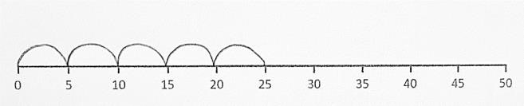  25 ÷ 5 = 6  Bar model representation:  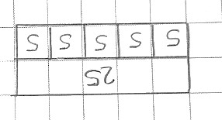 | Count on in steps of two, three and five from 0.  Skip counting on an unstructured number line, e.g:  25 ÷ 5 = □  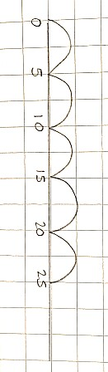  25 ÷ 5 = 6  Bar model representation: |  | Recall and use multiplication and division facts for the 2, 5 and 10 multiplication tables.  Number line or bar model to ‘prove it’  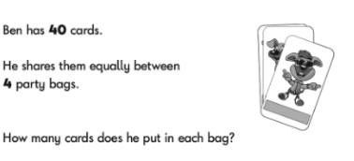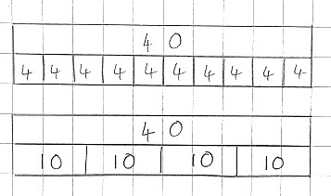  ‘Contains KS1 SATs materials licensed under Open Government Licence v3.0  Open Government Licence (nationalarchives.gov.uk)  “If I know that 4 x 10 = 40, then I know 40 ÷ 4 = 10”.  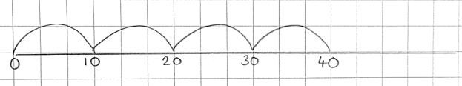

Southwood Infant School
Progression in Counting
 | NC Objectives for counting (other objectives) | Additional guidance based on NC objectives across maths domains | Examples | Resources to support modelling
Foundation | ELG  Children count reliably with numbers from one to 20, place them in order and say which number is one more or one less than a given number. | Count forwards and backwards from 0 to 20. | Count objects. Show me how to make number 5 etc. using different objects. Show objects with numbers on a number track.  Make sure children know teen numbers and the pattern. Order consecutive numbers and random numbers.  Recognise numerals.  Count from any number. Which number comes next/before- 1 more/less (fewer). | Counting objects  Number track to ten  Number line/track to 20.
Year 1 | Number  Count to and across 100  Forwards backwards  Start from 0 and any number. | Talk about place value of digits. What changes, what stays the same?  Count modelling as you go adding or taking away dienes or another concrete resource. | 0, 1, 2,3  87, 88, 89, 99, 100, 101, 102  109, 110, 111  102, 101, 100, 99 | 100 plus square  100 square  Number line
Year 1 | Fractions recognise, find and name a quarter as one of four equal parts of an object, shape or quantity. | Count in halves and halves and quarters over 1 whole. | ¼, ½, ¾, 1 whole | Cuisenaire to show fractions.

 | Number  count in multiples of twos, fives and tens | Count in 2p, 5p or 10p (**start to change the count step whilst displaying coins to aid addition) | 2p, 4p, 6p etc.  10p, 20p ** 25p, 30p | Coins real or models
 | Measures  tell the time to the hour and half past the hour and draw the hands on a clock face to show these times. | Count in ½ hr intervals using language of time. Progress to quarter hours  Days of week / Months of year | Half past 3, 4 o clock, half past 4 etc. | Clock face with rotating hands  Vocabulary cards showing days of the week/months
Year 2 | Addition and subtraction add and subtract numbers using concrete objects, pictorial representations, and mentally, including:  a two-digit number and ones a two-digit number and tens | Count on/back in 10s from any 2 digit number. (supports addition and subtracting tens)  Model with dienes | 34, 44, 54, 64 etc.  Count on 100 square, talking about the patterns.  Support through building the numbers using place value equipment. | 100 square  Base ten/Dienes  Place value mat
 | Multiplication and division  recall and use multiplication and division facts for the 2, 5 and 10 multiplication tables, including recognising odd and even numbers | Count in odd/even numbers (relate to count in 2s) only. | 5, 7, 9, 11  6, 8, 10, 12  28, 26, 24 etc.  15, 20, 25, 30 etc. | .

 | Fractions  Pupils should count in  fractions up to 10, starting from any number and using the and equivalence on the  number line e.g. ½ or 2/4  This reinforces the concept of fractions as numbers and that they can add up to more than one. 1 ¼, 1 ½ 1 ¾, 2, (nonstatutory guidance) | Count in halves and quarters over 1 whole- relate to measures. | ¼, ½, ¾, 1 whole  3 ¼, 3 ½ , 3 ¾ , 4 etc.  25cm, 50cm, 75cm, 100cm  (1m) and beyond | Number/Counting stick.  Cuisenaire to show fractions.
 | Number and place value count in steps of 2, 3, and 5 from 0, and in tens from any number, forward and backward  Measures  recognise and use symbols for pounds (£) and pence (p); combine amounts to make a  particular value | Count in coins of different values, changing the counting to support counting of money. | Count in steps of 2p, 5p, 10p Relate counting in 2s to counting in 20p, or 5s to 50p.  20p, 40p, 60p etc.  50p, £1, £1.50, £2  Adapting the counting to help add e.g. 10p, 20p, 30p, ** 35p, 40p, 45p (**shown coins to signify change in count step)
 | Number and place value count in steps of 2, 3, and 5 from 0, and in tens from any number, forward and backward | Count in 5 minute intervals around the clock (past hour) and to hour (from 12 anticlockwise). | 5 past, 10 past 15 minutes past (or quarter past) etc. | Clock faces with rotating hands
 | Measures  tell and write the time to five minutes, including quarter past/to the hour and draw the hands on a clock face to show these times | Use a curved number line to represent the clock face.

