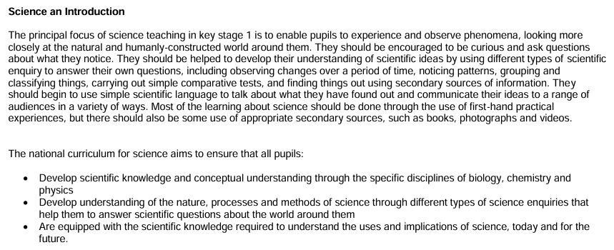

Strand ( as per NC) | Working towards ARE | ARE ( NC) | Beyond ARE
CHRONOLOGICAL UNDERSTANDING: sequence events/ objects chronologically, use words/ phrases relating to passing of time.

Chronological understanding | Can describe differences between themselves as a baby and as they are now  Sequences images of themselves as a baby, toddler, infant  Can sort pictures and objects, matching them to babies, children and adults  Understands and uses common words relating to the passing of time in the past, nowadays, a long time ago  Realises that images from nursery rhymes are not from nowadays by reference to some period detail e.g. clothes, objects no longer used.  Grasps that simple stories have a beginning middle and an end by correctly sequencing three episodes of a simple fiction or rhyme. | Creates simple timelines to sequence processes, events and  objects within their own experience e.g. stages of wash day, something very old, old and new.  More confident in use of terms old and new.  Uses terms then and now correctly and is comfortable with the term past.  Understands that the world was different in the olden days.  Can follow the logic of stories dealing with family generations.  Can sequence within clock and calendar times. | Can sequence parts of more complex stories where action takes place over a long period of time (e.g. realises that  Florence’s’ life can be divided into phases, before she went into nursing, when she was at the Crimea, the long period afterwards)  Children realise that we use dates to describe events in time e.g. 1666 for the Great fire of  London  Children can use phrases such as ‘over three hundred years ago’ in their writing. (Not necessarily because they grasp what that interval of time means but because they know that Historians use dates and phrases to mark the passing of time.

 | CHANGES BETWEEN WAYS OF LIFE AT DIFFERENT TIMES
Strand ( as per NC) | Working towards ARE | ARE ( NC) | Beyond ARE
Changes | Children can explain how life was different for them as a baby/ toddler.  Can identify the concept then and now. Children can spot significant differences between life then and now e.g. can describe that a building in the past might have been made of wood, that Guy Fawkes would not have a mobile phone to contact his conspirators. | Children can confidently distinguish between old and new objects. They can match old objects to people/situations for the past.  Children can describe how features of life today differ from the past and include subject specific detail.  In Y2 specifically children can focus on then, now and another then. E.g. Comparing the seaside today, Victorian seaside and 1930s seaside.  Children can offer a reason why a simple change occurred e.g. Why did children now play using technology, nit wooden toys as much. | Children display widespread, correct use of precise period specific terms.  Children begin to understand that not everyone in the past had the same experience. E.g.  understanding of rich queens/ servants/ poor familiarise having less happy time at Christmas in the past due to modest presents.
 | CAUSE AND CONSEQUENCE
Strand ( as per NC) | Working towards ARE | ARE ( NC) | Beyond ARE
Cause and  Consequence | Can explain why character in a simple story took the action they did. | Can offer simple consequence of somebody’s action E.g. because of the things Florence | Children can give the results (Consequence) of an event or persons actions. E.g. after the

 | Can explain why they themselves took the action they did.  Can give a simple reason why a person acted as they did in an historical situation. | Nightingale did, soldiers got better and hospital were cleaner.  Can give a clear explanation of important past event, offering 2 or 3 reasons why an events took place.  Children give a few reasons for more complex human actions  e.g. why someone might want to do something for the first time. | Great Fire of London, the streets were wider and houses were built of stone.  Pupils can give a few consequences of events/ people’s actions E.g. more able children could give a convincing explanation of why we remember Florence Nightingale.
HISTORICAL ENQUIRY

Strand ( as per NC) | Working towards ARE | ARE ( NC) | Beyond ARE
Historical Enquiry | Can find answers to questions by looking at simple images.  Children can sort photographs of themselves and their peers into groups for babies, toddlers and school children and explain their choices.  Children can describe the main features of an historical artefact.  Can explain how we know what we were like when we were younger. E.g. photos, videos, grandparents telling stories. | Children can make deductions about artefacts spotting clues to function and use and can talk about them.  Children can find answers to questions by looking at secondary sources such as books or the internet.  Children can compare information from two simple courses to confirm ideas.  They realise they can find out about the past from a range of sources. | Children are able to gather ideas from a few simple sources.  Children realise there may be weaknesses in individual accounts due to bias or physically limited view or experience of an event.

Children can ask simple, but relevant questions of adults about their past or of a teacher in role.

Children can draw conclusions about their own lives and others around them by reference to clues in evidence.
HISTORICAL INTERPRETATION

Strand ( as per NC) | Working towards ARE | ARE ( NC) | Beyond ARE
Historical  Interpretation | Children know that a familiar event like a birthday can be represented in different ways  e.g. photo, video, mementos such as birthday cards.  Children to begin to understand that we have different view of familiar events. We cannot always remember what happened in the past.  Children can see that there are several versions of a story and identify the differences between them. | Children can see that there are different versions of real historical situations.  Children identify differences of accounts/ images of the same historical event.  Children realise there may be more than one way of looking at a significant historical person or event both at the time and in the present.  Children realise not all sources of information answer the same questions. | Children can see that not accounts give exactly the same reasons for something.  Children understand that people can disagree about what happened in the past without one of them being wrong. This is an important idea in history.
 | COMMNICATION: Ways in which pupils demonstrate their knowledge and understanding
Strand ( as per  NC) | Working towards ARE | ARE ( NC) | Beyond ARE
Communication | Can talk about their lives using appropriate vocabulary.  Will write simple captions, some will write elementary sentences to describe for example an old teddy.  Can label/ annotate simple illustrations showing aspects of life in the past.  Children can orally retell the main episodes of famous past events in the correct sequence. | Children can write four or five captions to accompany sequences pictures, possibly using connectives to show sequence of events.  Increasing use of period vocabulary orally.  Children show an awareness of significant features not seen today.  Children include some period specific vocabulary/ detail in their writing.  Children can retell a complicated story in simple structured way. Children can explain the events and actions rather than just retell the story using words and phrases such as because, the reason was… | More use of time conventions when writing in history.  Increasing use of subject specific vocabulary and inclusion of period details both orally and in written work.  Far less evidence of anachronism, showing a more basic awareness of period.

