

Pupil premium strategy statement 2024-5

This statement details our school’s use of pupil premium funding to help improve the attainment of our PP pupils.
It outlines our pupil premium strategy, how we intend to spend the funding in this academic year and the effect that last year’s spending of pupil premium had within our school.

School overview
Detail | Data
School name | Southwood Infant School
Number of pupils in school | 117
Proportion (%) of pupil premium eligible pupils | 6%
Academic year/years that our current pupil premium strategy plan covers (3 year plans are recommended) | 2024 / 25
Date this statement was published | December 2024
Date on which it will be reviewed | July 2025
Statement authorised by | Zoë Wisken  Headteacher  Resources Committee of the  Governing Body
Pupil premium lead | Luci Roberts
Governor / Trustee lead | Hannah Stiff

Funding overview
Detail | Amount
Pupil premium funding allocation this academic year | £7,885
Recovery premium funding allocation this academic year | £1200
Pupil premium funding carried forward from previous years (enter £0 if not applicable) | £0
Total budget for this academic year  If your school is an academy in a trust that pools this funding, state  the amount available to your school this academic year | £9085
Part A: Pupil premium strategy plan

Statement of intent
Southwood Infant School is a small Infant school in Farnborough, Hampshire. We have a unique semi-open plan building and outside areas that are used throughout the school for learning. Being a small school we have the advantage of being able to know all children as individuals and we are a fully inclusive school.
Due to our small size (117 on roll) and school context, we have a low percentage of children in receipt of the Pupil premium grant (6%), and we also have a low number of children that we consider vulnerable. However, as a school we strive to ensure all children achieve well both academically and socially and emotionally irrespective of their background or challenges and we pro-actively look for help, support and resources to meet all our children’s needs. Currently, 70% of the children in receipt of the pupil premium grant are also on the SEND register, or are receiving additional interventions and support linked to other areas.
The focus of this plan is to show how we aim to improve the outcomes for our PP children, including those who are already achieving in line with their peers in some areas regardless of their background or challenges.
At Southwood all staff analyse the performance of all children, including our Pupil premium children, regularly throughout the year with the HT and Pupil premium lead. Our PP children are discussed in our weekly staff meetings where we have a standing agenda item on vulnerable children. Any additional needs are identified quickly and are monitored robustly. We meet with parents to ensure we have a good understanding of the child’s home context. All children in receipt of the funding have a bespoke tracking ‘passport’ which allows us to ensure they are making good progress and to help us analyse any barriers to learning.
The activities outlined in this statement, intend to show ways in which we use the funding available, based on this assessment of need to help the children make good progress, and to achieve in line with their peers- both academically and social and emotionally.
This approach means we can:
- Ensure work is appropriately challenging, robust and targeted towards an individual’s needs.
- Review/ Evaluate and change individuals plans as needs arise, to ensure that the support is the most effective
- We have a whole school approach and accountability to meeting these children’s needs, with a number of staff- from class teachers, LSAs, ELSAs and external staff such as tutors- all contributing towards the child’s success.
- Provide appropriate pastoral support
Well planned sessions with high quality teaching, as well as emotional support, such as ELSA sessions, are at the heart of our approach. As we have such a small number of children, we are able to create individual programmes tailored to the needs of each child, with some requiring more formal academic teaching, with others requiring ELSA support, and time to meet and support parents and carers. We believe that high quality teaching is the key to the children’s success.

Challenges
This details the key challenges to achievement that we have identified among our PP pupils.
Challenge number | Detail of challenge
1 | Assessments and reports from class teachers show poor reading skills for some of our PP children, mostly linked to other areas of need such as Special Educational Needs. For most of the children, it is phonics skills that they need to work on, in order to move their reading on. Language link assessments for these children show a good understanding of language.
2 | Current assessments/ observations and class data show children in receipt of the pupil premium grant find writing challenging, again linked to lower reading skills, with children finding it hard to use their phonics knowledge to record their sentences accurately.
3 | Assessments/ observations/ reports and class data shows that 50% of the children in receipt of the pupil premium grant are not achieving in line with their peers in Maths, in particular in number and counting. We continually review the planning and where appropriate IEP targets for the children, to ensure the correct balance of the concrete, pictorial, abstract approach as well as lots of opportunities to support and reinforce maths understanding.
4 | Our attendance data shows that our Pupil Premium group have lower attendance rates by the end of the academic year. School policies ensure that those with poor attendance are targeted with interventions and support to raise attendance. These are detailed on our CPOMS system and include support meetings, meetings with the Headteacher and the work with the class teachers to ensure we are supporting better attendance in school.

Intended outcomes
This explains the outcomes we are aiming for by the end of our current strategy plan, and how we will measure whether they have been achieved.
Intended outcome | Success criteria
Improved phonics skills amongst PP pupils so they are achieving in line with their peers within phonics. | End-of-year phonics assessments indicate that all PP pupils demonstrate significant progress from their initial levels. This progress will be continuously monitored throughout the year using our bespoke tracking system.
Improved reading attainment amongst PP pupils. | End of Key Stage One data indicates that all PP pupils exhibit significant progress from their initial starting points. Parental engagement meetings reveal enhanced home support for reading. Additionally, PP children demonstrate notable improvement in their SALFORD reading scores, effectively narrowing the gap with their peers
To monitor and improve where necessary attendance for our PP pupils. | Half-termly attendance data indicates an increase in attendance for all children. Meeting logs and letters from the Headteacher document actions taken to address persistent poor attendance. The school-wide implementation of the Mastering Number program enhances children's rote understanding of number facts, empowering them to continue their learning at home and supporting families in reinforcing this knowledge.
Improve the writing skills of our PP children, so they are achieving in line with their peers by the end of Key Stage One. | End of Key Stage One Data shows that all children make good progress from their starting points and close the gap between their peers.

Activity in this academic year
This details how we intend to spend our pupil premium (and recovery premium funding) this academic year to address the challenges listed above.

Teaching (for example, CPD, recruitment and retention)
Budgeted cost: £ 7885
Activity | Evidence that supports this approach | Challenge number(s) addressed
Use of  Standardised Testing and data to make diagnostic assessments and to track progress.  Improve use of over-learning/retrieval practice opportunities,  E.g. SALFORD reading test  Language Link  DEST Screening Check  Phonics screening check  PM Bench marking | Standardised testing allows us to have clear starting points and can be used to identify areas for development and to ensure interventions are targeted appropriately. They can also be used to track and monitor progress/ improvements against targets and previous attainment.  https://speechandlanguage.info/resources/perch/pdf/infantlanguage-link-technical-report.pdf  https://d2tic4wvo1iusb.cloudfront.net/documents/news/Diag nostic_Assessment_Tool.pdf | 1, 2,
In line with new Government requirements, we are conducting a review of our current phonics scheme with a view to implement a new scheme from Jan 2022. This has been implemented and already shows an impact on learning. | Phonics approaches have a strong evidence base to show impact on the accuracy of decoding (it should be noted that Comprehension is not necessarily improved)  https://educationendowmentfoundation.org.uk/educationevidence/teaching-learning-toolkit/phonics  https://www.littlewandlelettersandsounds.org.uk/ This is the Phonics scheme adopted by our school. Also shown are the links for children needing additional support  https://www.littlewandlelettersandsounds.org.uk/whats-included/rapid-catch-up/  https://www.littlewandlelettersandsounds.org.uk/whats-included/send/ | 1
PP Lead time – Planned Release time on a half termly basis for the PP lead to support and develop practice for our PP children. | This is practical support offered to ensure other targets/ interventions are embedded and understood by teachers and other teaching staff. | 1 2 3 4 5
ELSA time – targeted ELSA support for those children whom need social and emotional support to access their learning and to reduce anxiety. | This is good evidence to show the academic improvements and mental wellbeing of children who work to improve their social and emotional skills. It is worth noting this evidence suggests regular short bursts are the most effective- which is why we have timetabled in this way in school.  https://educationendowmentfoundation.org.uk/educationevidence/teaching-learning-toolkit/social-and-emotionallearning | 5

Targeted academic support (for example, tutoring, one-to-one support structured interventions)
Budgeted cost: £1200
Activity | Evidence that supports this approach | Challenge number(s) addressed
In line with new  Government requirements, we are conducting a review of our current phonics scheme with a view to implement a new scheme from Jan 2022.  In addition to this some children will undertake Booster phonics sessions. . This has been implemented and already shows an impact on learning. | Phonics approaches have a strong evidence base to show impact on the accuracy of decoding (it should be noted that Comprehension is not necessarily improved)  https://educationendowmentfoundation.org.uk/educationevidence/teaching-learning-toolkit/phonics  https://www.littlewandlelettersandsounds.org.uk/ This is the Phonics scheme adopted by our school. Also shown are the links for children needing additional support  https://www.littlewandlelettersandsounds.org.uk/whats-included/rapid-catch-up/  https://www.littlewandlelettersandsounds.org.uk/whats-included/send/ | 1,2
ELSA/ SNA session- targeted ELSA support for those children whom need social and emotional support to access their learning and to reduce anxiety. Within class support from LSA to develop concentration and focus skills. | https://www.hants.gov.uk/socialcareandhealth/publichealth/hampshirehealthi neducation/keystages/secondary/emotionalwellbeing  https://educationendowmentfoundation.org.uk/education-evidence/teachinglearning-toolkit/teaching-assistant-interventions | 1,2,3, 5

Wider strategies (for example, related to attendance, behaviour, wellbeing)
Budgeted cost: £0 – no additional cost- training provided in staff meeting time and as part of our TA programme.
Activity | Evidence that supports this approach | Challenge number(s) addressed
TA training – lead by the leadership team to support different approaches to help scaffold learning. | Classroom observation evidence shows that teaching assistants in our school respond well to targeted training and we see resources and methods shown being used within lessons and to support children. | 1,2,3,5
Improving school attendance – all staff to receive background reading, training and support to improve attendance. | Working together to support attendance guidance training given to staff annually  School policy updated in accordance with the above guidance | 4

Total budgeted cost: £ 9085
Part B: Review of outcomes in the previous academic year

Pupil premium strategy outcomes
This details the impact that our pupil premium activity had on pupils in the 2022 to 2023 academic year.
Please see the link below to last year’s pupil premium report detailing actions.
https://www.southwoodinfantschool.co.uk/page/?title=Pupil+Premium+Strategy&pid=46
There were 7 children in receipt of the pupil premium funding in the academic year 2022/3 who were assessed in June.
Overall the strategy was successful. Although the majority of pupils made good progress from their starting points, some were unable to be assessed as meeting Age Related Expectations (ARE).
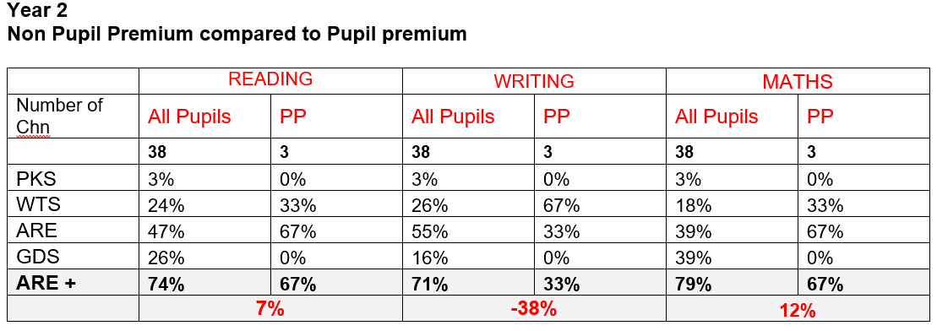
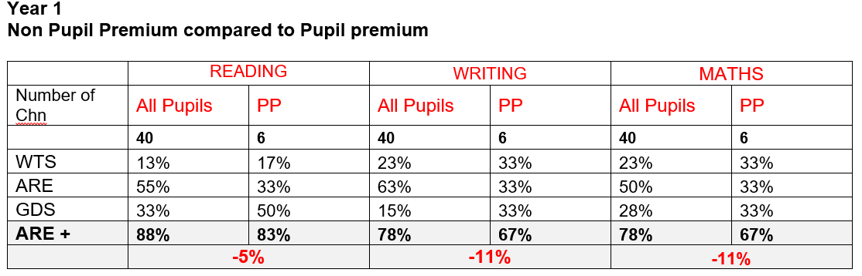
Additional sessions for children PP children were well planned and executed. Due to a range of circumstances other children did not achieve end of year expectations, those reasons were tracked via the children’s passports and were additional support/ involvement was needs such as work with an Educational Psychologist- this interventions took place.

Externally provided programmes
Please include the names of any non-DfE programmes that you purchased in the previous academic year. This will help the Department for Education identify which ones are popular in England
Programme | Provider
Language Link (renewed on a yearly basis) | Speech Link Multimedia Limited
Little Wandle Phonics Programme | Little Wandle

Service pupil premium funding (optional)
For schools that receive this funding, you may wish to provide the following information:
Measure | Details
How did you spend your service pupil premium allocation last academic year? | For our service children, we offered additional class based session with a designated adult to support individual needs. We run a forces club and hold themed days to support social and emotional development and communication with families.
What was the impact of that spending on service pupil premium eligible pupils? | Our 3 service children all achieved ARE/ GDS or GLD.

Further information (optional)
As a small school, we are able to monitor this group of children very effectively and create a bespoke experience for all. As a staff it is a standing item on every week’s staff meeting agenda- to discuss any needs/ strategies/ successes we have found and this helps keep the staff focussed on supporting these children and means we can have a whole school approach towards giving these children the best outcomes possible. When needed we are able to access additional support such as our local Mental Health support team network to work with families for additional support.

