

Home Learning – Year 1
Giraffes can’t dance by Gilaes Andreae and Guy Parker Rees
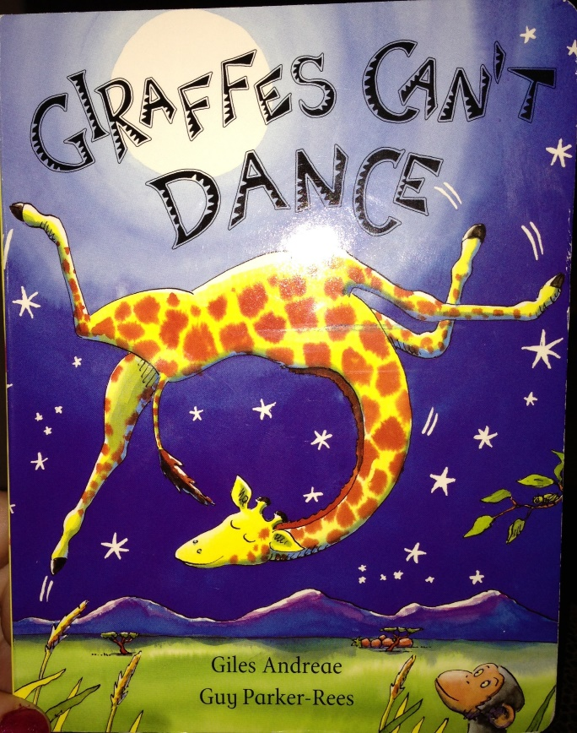
Welcome to the Home Learning Page for children who are isolating at home. This unit is aimed at children who are in Year 1. This planning block covers two weeks work and is split up into different subject areas. The idea is that all of the work should be completed by the end of the two weeks, however you can choose which activities and subjects you do each day and how you arrange this, so it can suit your family and circumstances.
Typically, in school we have core subjects first (Literacy or Maths), then phonics or handwriting with a topic or PE activity later- so you might find it useful to structure your day in a similar way. Each box is one session. You can record your work using Tapestry, or in a way that suits you e.g. as word documents, on paper and you can bring the work in when your child returns to school so that we can see all the Home learning. We have deliberately not written the planner as a set sequence e.g. day 1 teach these 5 lessons. We have planned over 40 sessions for 10 days.

Please start by reading the book Giraffes Can’t Dance, there is a PowerPoint attached in the Home learning planner, or there are several retellings on You Tube.
https://www.youtube.com/watch?v=E92XNvCoeWo
https://www.youtube.com/watch?v=Zzb5Acl-n70 (song)

Areas of Learning
Literacy- Reading and writing |  | Literacy – Speaking and Listening | Maths |  | Physical Education
Find a book review format you like online and complete a review of Giraffes Can’t Dance- try to use ‘because’ to explain your reasons. | Find the page where Gerald listens to the swaying grass, and the trees. Close your eyes and listen to the sounds you can hear. Write simple sentences using capital letters and full stops to describe what you can hear when you close your eyes. | Make simple puppets for some of the animals in the story- this could be drawings/ spoons/ lolly sticks (There are lots of ideas for puppets linked to this story online). Once you have the puppets can you retell the story? You could record it to make a video. | Can you count the number of animals on each page in the book? Make sure you count accurately pointing to a different animal each time you say a number. Can you write down those numbers? Which page has the most animals? | Can you count to 50? Try counting forwards and backwards.  Try counting from any number eg. count up to 50 starting at 13. | Look up some of the dances mentioned on You tube (the Waltz, Rock and roll, Tango, Cha cha cha, Scottish reel)  Can you have a try at the dances as a family?
Can you come up with some ideas for others books with the same theme e.g. Pigs Can’t Roller-skate, Elephants Can’t Swim. Discuss what would make a good story. | Practise simple sentences using ‘and’ and for an extension ‘because’. Relate them to the story.  Gerald could hear the trees and the grass.  Gerald was sad because he could not dance. | Can you add some speech bubbles to the animals in the story? What would they say if they could speak? (This is a talking activity so your mum or dad could do the writing for you) You could cut speech bubbles out of paper and blu tac them on. | Find some animal toys at home or cut out some animal pictures. Can you find different ways to sort them? eg. colour, number of legs, where they live, size etc. | Use your animal toys or pictures to make up your own maths problems eg. If there are 3 penguins how many feet do they have altogether? Record by drawing and/or writing the number sentence eg. 2+2+2=6 | Can you set up a dance contest in your garden, like the one in the story? You could take it in turns to dance or play musical statues as a family.
Draw and describe the animal you have chosen to feature in your story. Surround the drawing with adjectives you could use in your story – grey elephant, ling trunk, hairy toes, and shiny tusks. | Make a plan for your story- what will happen at the beginning, middle and end. (For example the elephant couldn’t swim, then there was the annual river swimming contest, a warthog taught him how to swim, he was able to enter the river swim!)  You can record this plan using drawings and notes | Create an oral news report on the jungle dance contest. Can you report on Gerald’s performance! You might even want to record it and make a microphone to help you. | Gerald has 10 spots, some are triangles and some are circles. How many could be circles and how many could be spots?  You could do this practically with objects or draw each possibility.  Can you write them as number sentences?  eg. 5+5=10 | Practise your number bonds to 10 (2 numbers that add together to make 10) with these games:  https://pbskids.org/curiousgeorge/busyday/ten/  https://www.ictgames.com/saveTheWhale/index.html | Put the numbers 1-6 in a bag. On a poster write down different activities that you need to do for 1 minute for each of the numbers e.g. 1 star jumps, 2 press ups etc. Take turns to pull an exercise from the bag and see if you can complete it for one minute.
Story writing session one- begin to write your story. Focussing in finger spaces,  capital letter and full stops. | Story writing session Two- complete your story. |  | Practise ordering and sequencing numbers with this caterpillar game:  https://www.topmarks.co.uk/ordering-and-sequencing/caterpillar-ordering | Can you make your own numberline? Try to write all the numbers up to 30 (go to 50 if you can!)  This can be done however you like indoors or out! | Choose an exercise video from Jump Start Jonny  https://www.jumpstartjonny.co.uk/home  And have fun working out.
Make an assault course in your back garden or sitting room.
How quickly can you complete circuits of the course?
Religious Education | Phonics |  | Personal, Social and Health Education | Topic Activities
In KS1 we learn about the Jewish faith and the Christian faith but also recognise and share the faiths of all of the children in our school where relevant to the learning as well as understanding that some children don’t have a particular faith. With that in mind could you find out if any of the faiths (Jewish, Christian, Muslim, Hindu, Buddhism, Sikhism) have stories about the sea or sea creatures?  This is a general understanding that some people have a faith and even if we don’t we can learn about faith in its broadest sense. | The book is written in rhyme. Can you go through and find the rhyming pairs. Can you think of other words that rhyme with each pair? You could record this in a list. | Week One Spelling Test  Chose 5 of the words in the 100 first word list below that your child does not know how to spell and use these as the focus for the spelling test, using the same look, say, cover and hide and check method we use for spellings in school. | Discuss how Gerald feels on the page where he turns up at the Jungle dance. Why do you think he is sad? What other things make people sad? In the story the friendly cricket helps Gerald. What can we do if we feel sad? | ART  Make a Collage Giraffe. Can you find objects around your house to help you make the different colours e.g. yellow magazines, leaves, poms poms, tissue etc.? You might even want to make your collage 3D so your Giraffe stands yup. | ART  On the Jungle Dance page there is a sunset in the background. Can you colour mix different shades of yellow and red paint to make oranges and other sunset shades to create a sunset design. (See images below)
Once you have found a story that you really like draw a storyboard of the beginning, middle and end.  Does it have a special meaning to the people of the faith?  Do you have a story that is special to you?  Why is it special to you? | Find the page in the book where the chimps do the cha cha cha. Can you make a ‘ch’ poster? You could write down things that start with ch, or cut them out of magazines and stick them on. | Week Two Spelling Test  Chose another 5 of the words in the 100 first word list below that your child does not know how to spell and use these as the focus for the spelling test, using the same look, say, cover and hide and check method we use for spellings in school. | Following on from last session on being ‘sad’ can you make a poster of different emotions. Discuss when you might feel happy, angry, excited, nervous etc. Reinforce the message that it is fine to feel different emotions. | GEOGRAPHY  Research where Giraffes are from. What can you find out about Sub-Saharan Africa? Use a globe, google Earth to find out more. What other species live there? | DESIGN AND TECHNOLOGY  Can you design a new home for Gerald? You could use junk modelling materials and practise your joining skills. You might want to draft a design first. What special features will it have? A dancefloor? Watering hole? If you do not have junk modelling bits available you could use Lego or other construction toys.
Science  Link to the Geography activity- what is the habitat like in Sub Saharan Africa where the story is set? Can you find out about the weather and vegetation? How does it compare to the habitat in Southwood? | Play an online phonics games like Picnic on Pluto or Buried Treasure.  www.phonicsbloom.com  www.phonicsplay.co.uk  Choose sounds from Phase  3 or 4 | Play an online phonics games like Picnic on Pluto or Buried Treasure.  www.phonicsbloom.com  www.phonicsplay.co.uk  Choose sounds from Phase 3 or 4
Find out about another habitat (Artic, Rainforest etc.) and compare and contrast with Africa/ Southwood. You might want to make a list of what is the same and what is different. | Can you start with a simple CVC (Consonant Vowel Consonant) word e.g. cat, can you change one letter at a time to make a new word. E.g. cat, can, fan, man, mat, sat, sit, six. How long can your string be? | Write down lots of vowels and consents on a piece of paper (Include ch, th and sh)  Pull letters from the vowel bag and consonant bag. Can you rearrange them to make a word? Is it a real word or a fake word? E.g. farb, that
Can you create a jungle animal fact file? You might want to focus on a particular animal form the story, or find out lots of facts about different animals. | Choose some of the words from the list below and write them on paper or post its. Stick them around the house and garden- use these as targets. If you can read the word you can throw a soft ball at them or hit them with a nerf gun bullet. | Use www.ictgames.com to play some of the phonics game. Phoneme pop if a favourite in school.


